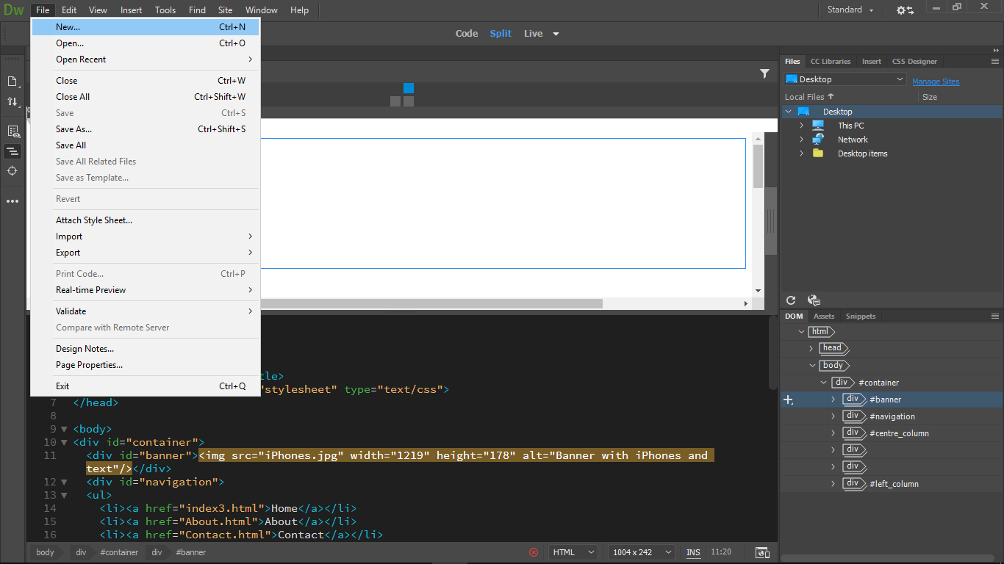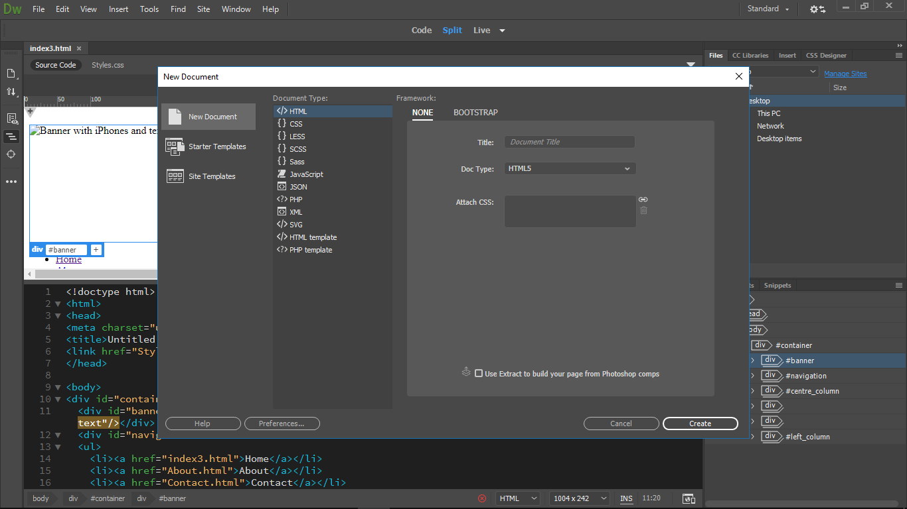

1. To open a new document, I needed to go to file, click on “New…” and when “New Document” popped up, I selected HTML as the Document Type and clicked on the “Create” button, then saved it as “index.html” in a folder which only contains everything I needed to create the website.
2. 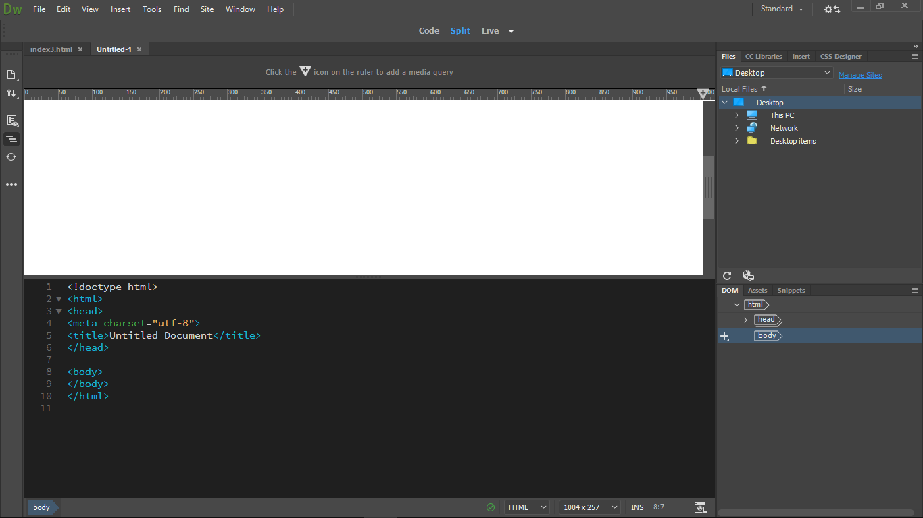After the first step, I saw that I had this in the code section, and also an empty sheet right above it.
3. 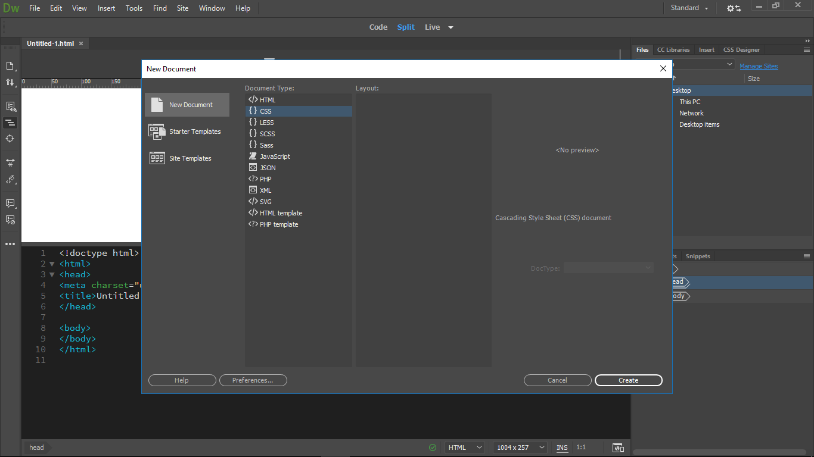To create rules, I needed a “styles Sheet”, so to create it, I had to go to file again, click on “New…” and select “CSS” this time. After I created it, I saved it as “styles.css” in the same folder I saved my index.
4. 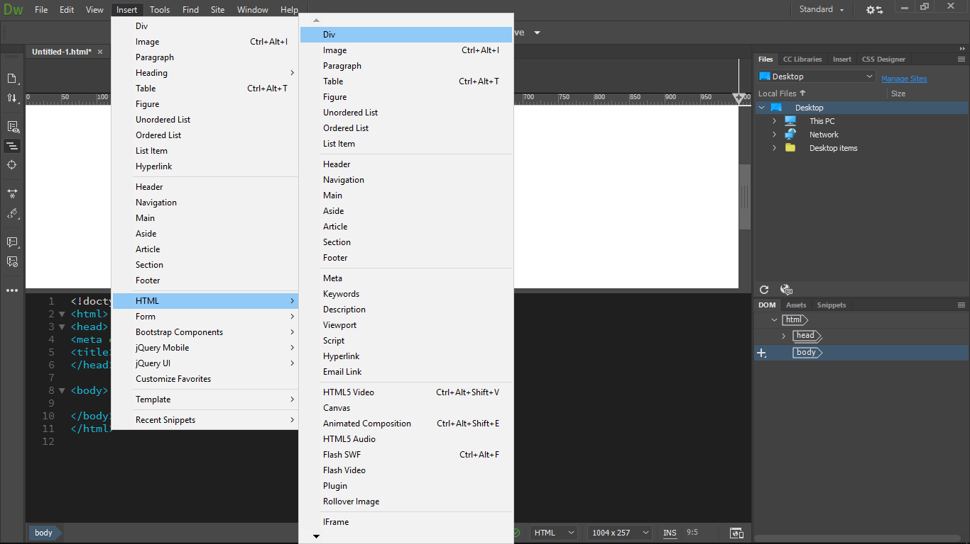Next, I needed to create a div tag called “container”, which will be placed inside the body tags.

To do this, I went to “Insert” -> HTML, then selected “Div”.

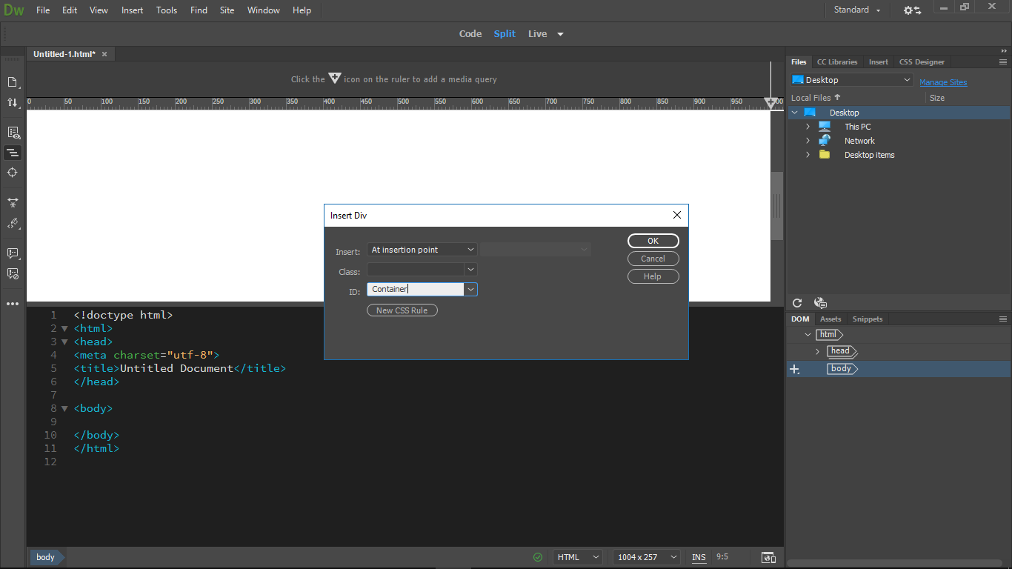 When “Insert Div” came up, I just wrote “Container” into the “ID” text box and then clicked OK.

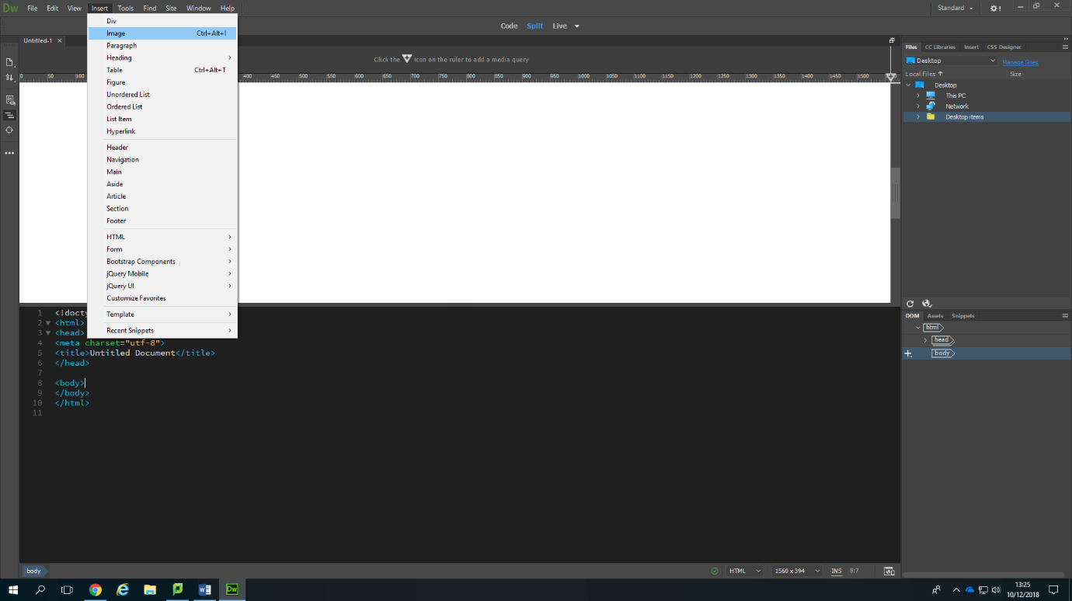

1. After creating the container, I decided to start with adding the banner that I created using Photoshop. To do this, I needed to go to “Insert” again, select image, then select the image that I needed.
2. 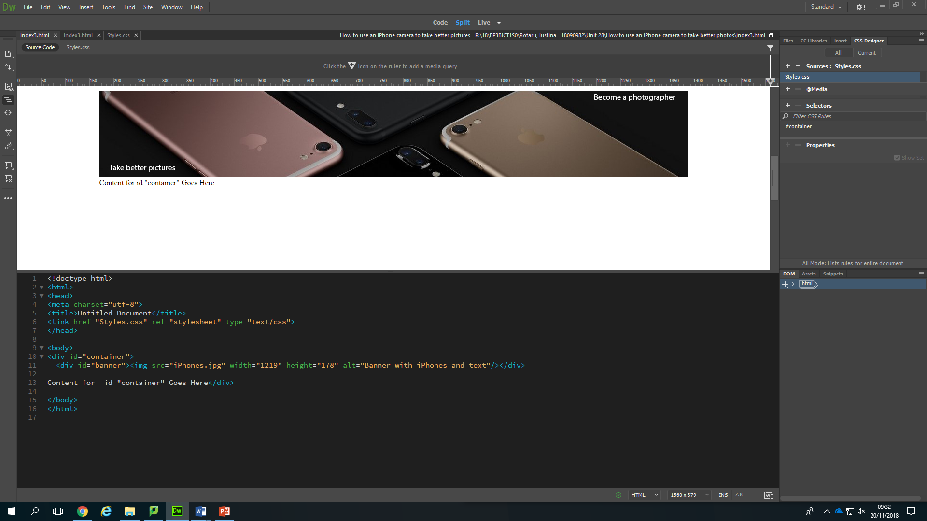After I inserted the image, I wrote a short description of it, in case the picture is not visible for some users, or they are using screen readers.

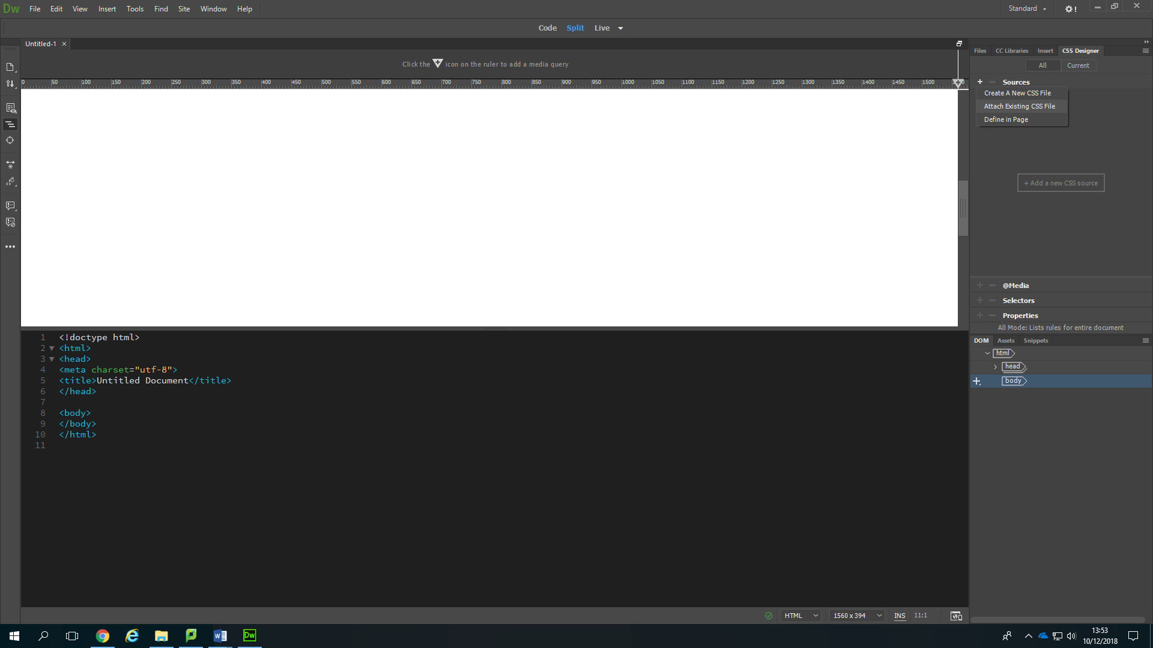

1. The banner has been added, but it wasn’t centred so I had to go to my styles sheet, to create a rule for the container div, but first, I needed to attach it to the other sheet, so I went to “CSS Designer” -> Sources -> “Create A New CSS File.

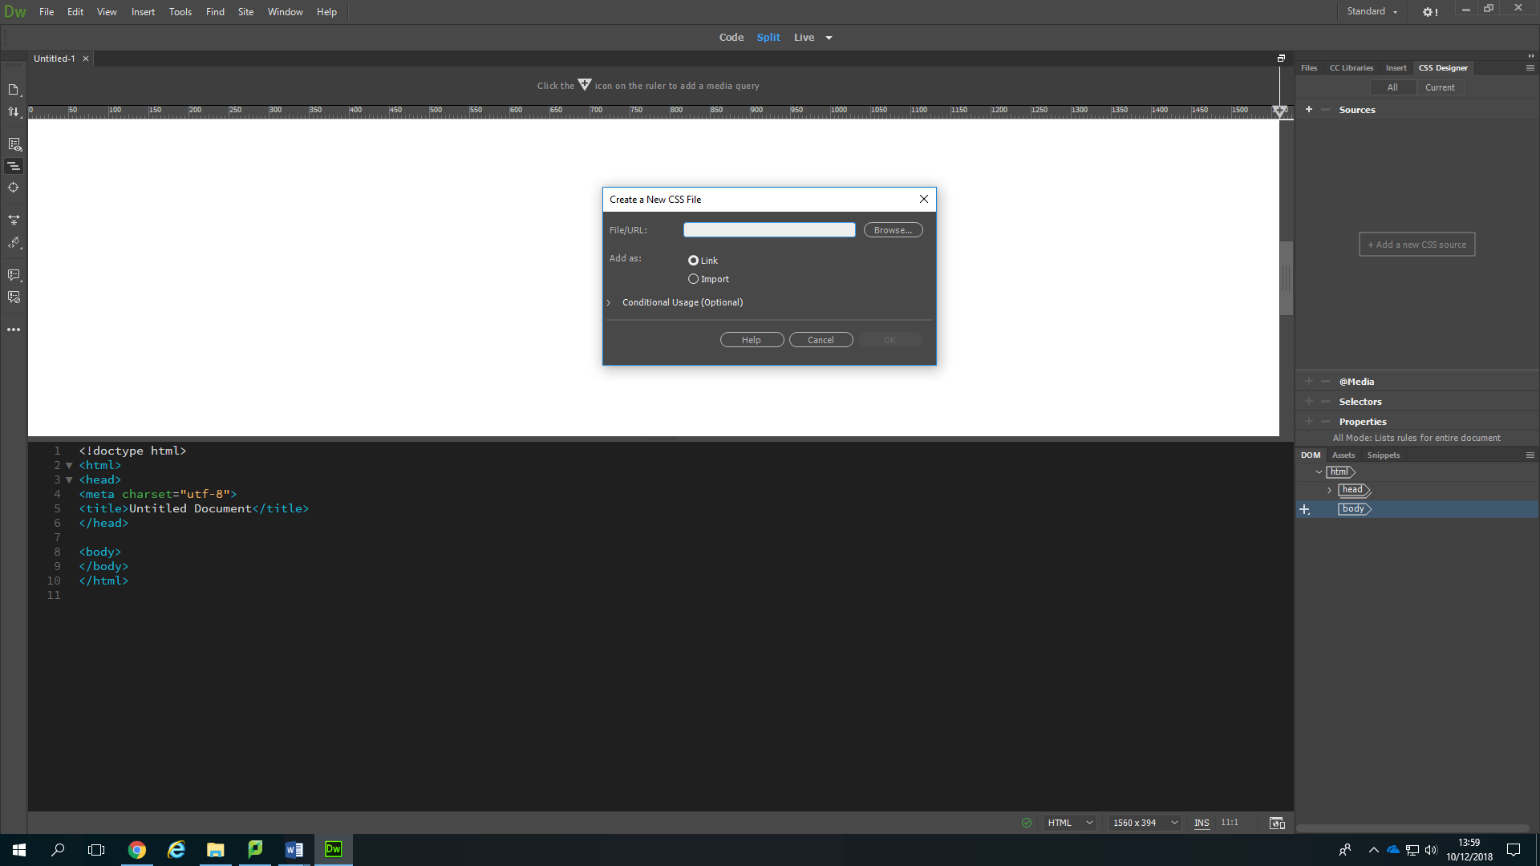

After this I had to click on “browse”, then find my “Styles.css” and select it.

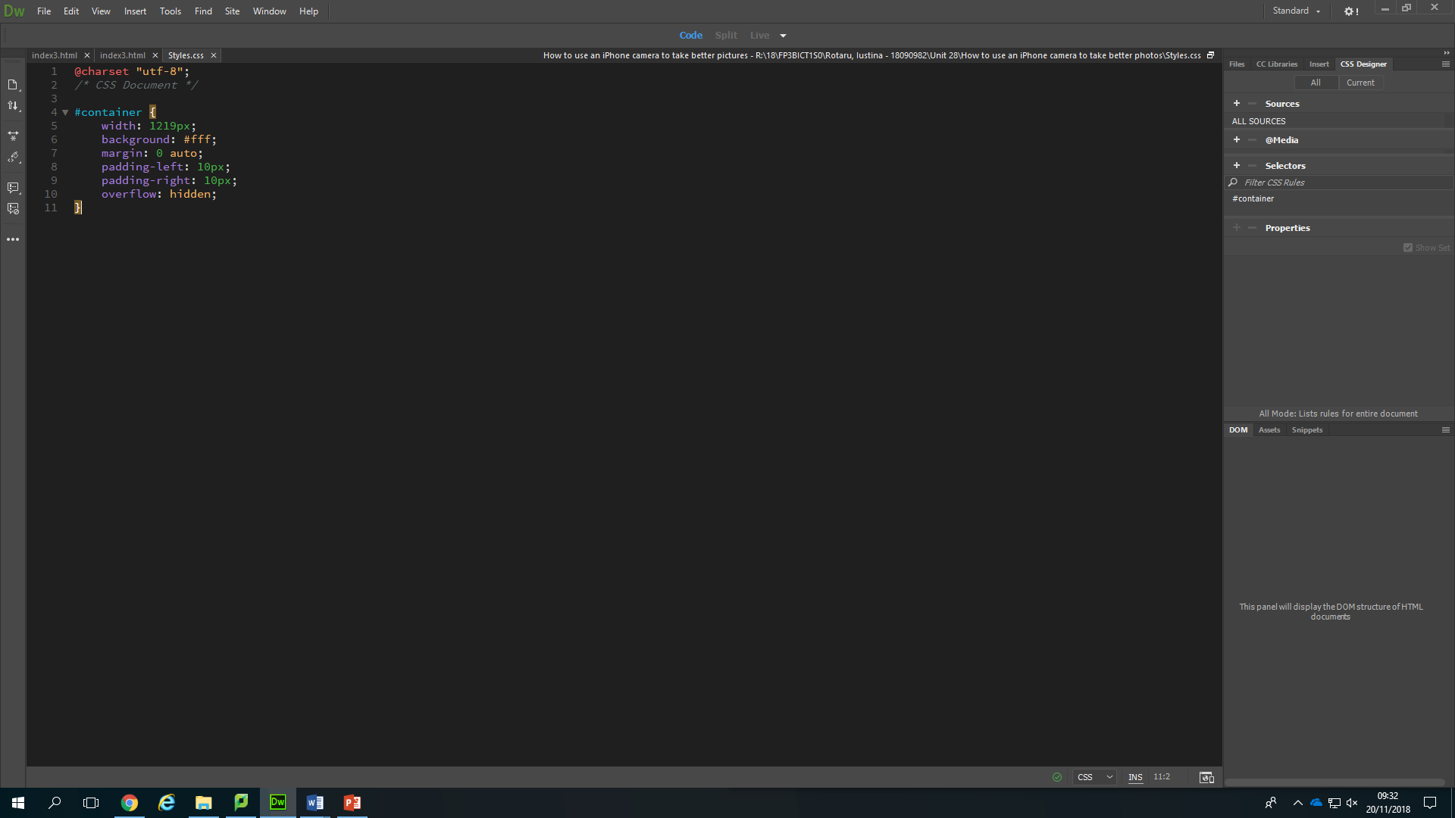

1. After step 7, I started writing my rules. First, I set the width to my banner’s width, then the background colour to grey, the margins to 0 pixels, to centre the whole container in the middle of the page and the paddings left and right to 10 pixels, all by writing these rules.

Darkgray;

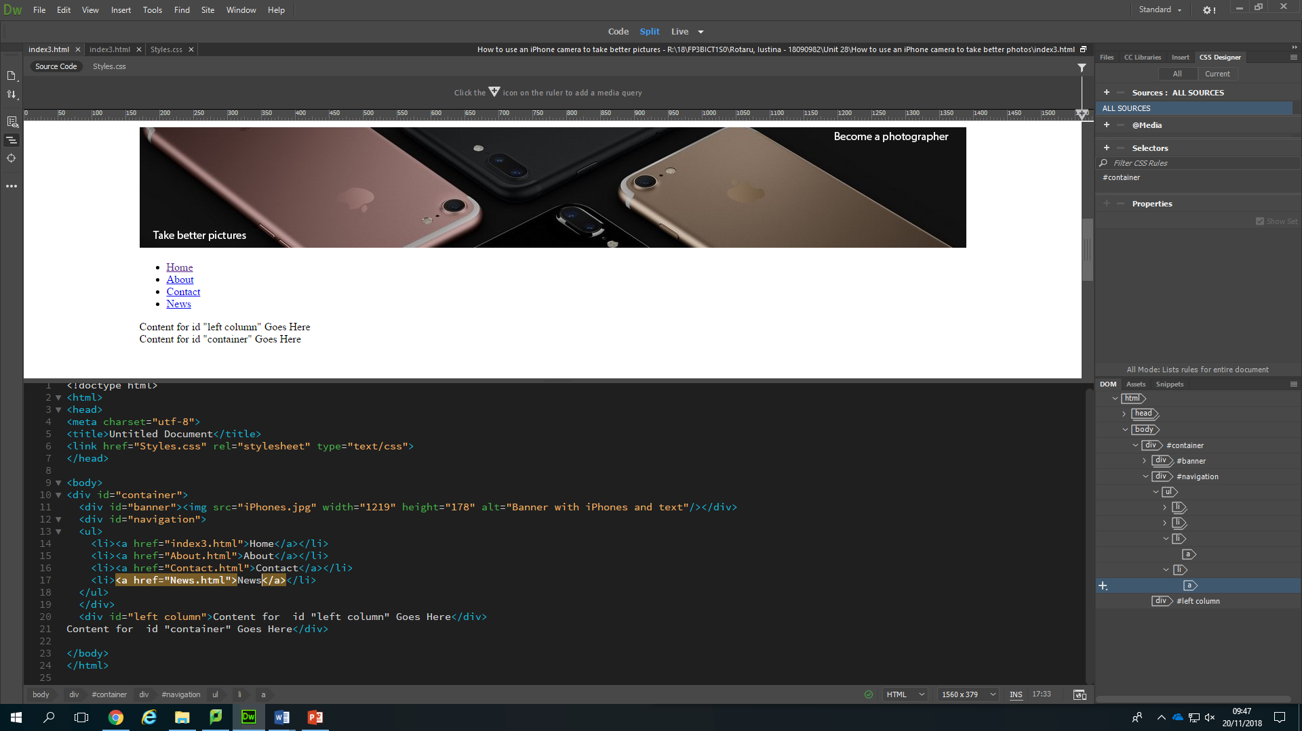

1. Next, I decided to start creating my navigation bar. The first thing I needed to do for that was to insert another div tag called “Navigation”, then write all these, that will create my buttons.

(as I was continuing my website, I decided later on that I should change my “News” with “Apps”)

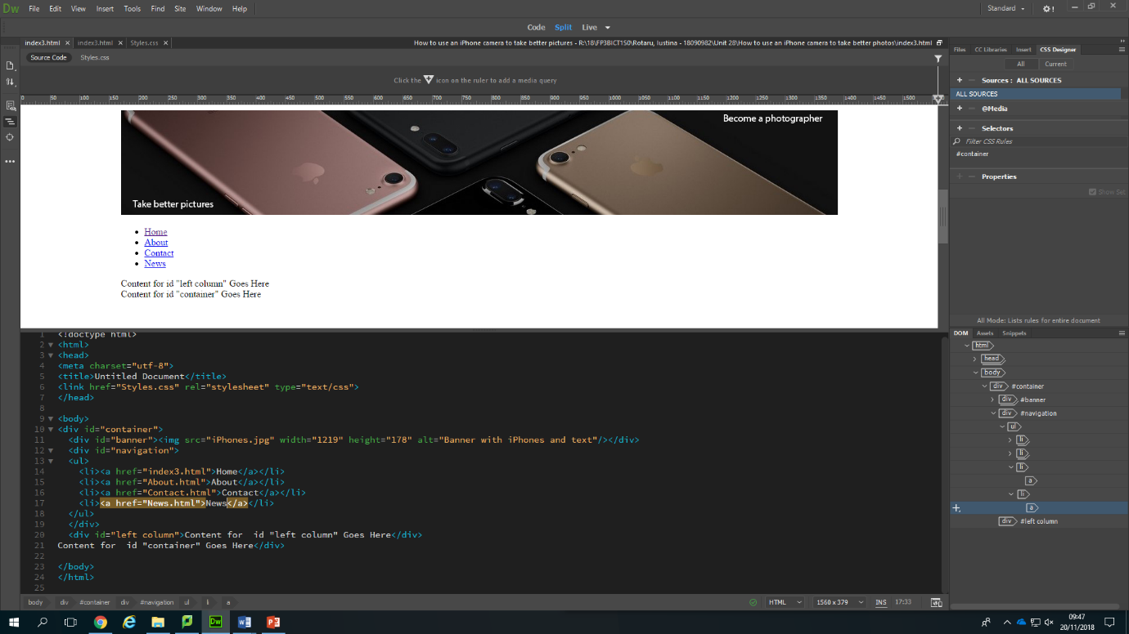

This is what my Website looked after doing all these.

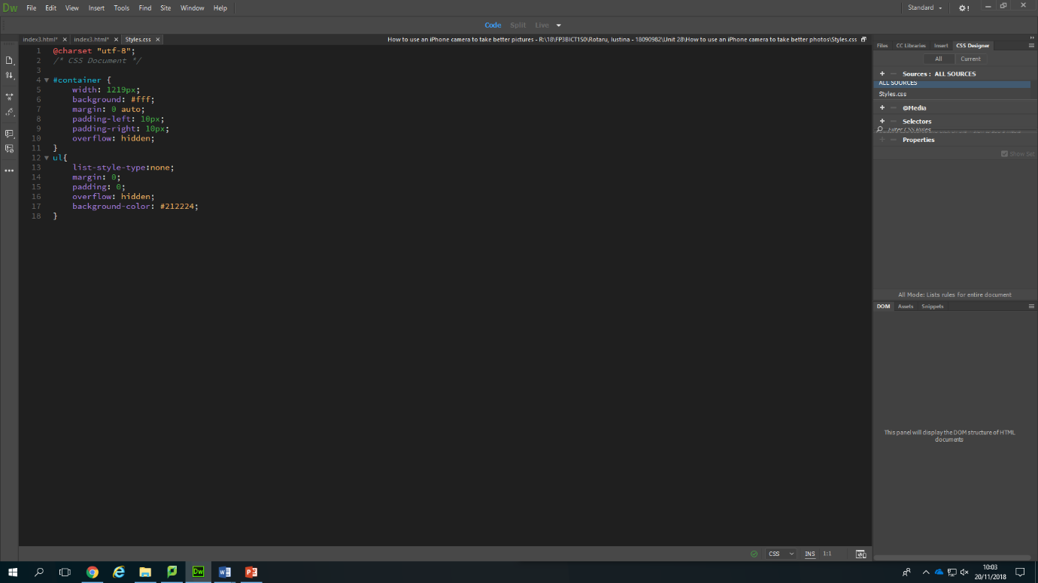

1. By writing these rules for my list, I removed the bullet points, I set the margins and paddings to 0 pixels and changed the background colour to a dark grey.
2. 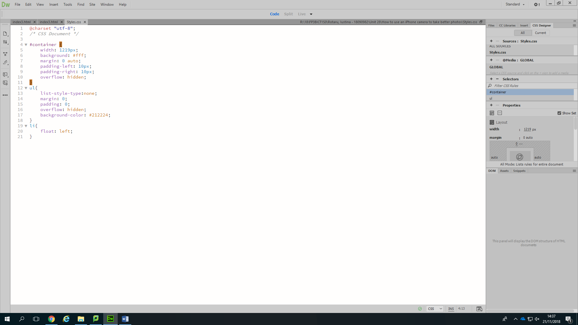 Makes the items float to left.
3. 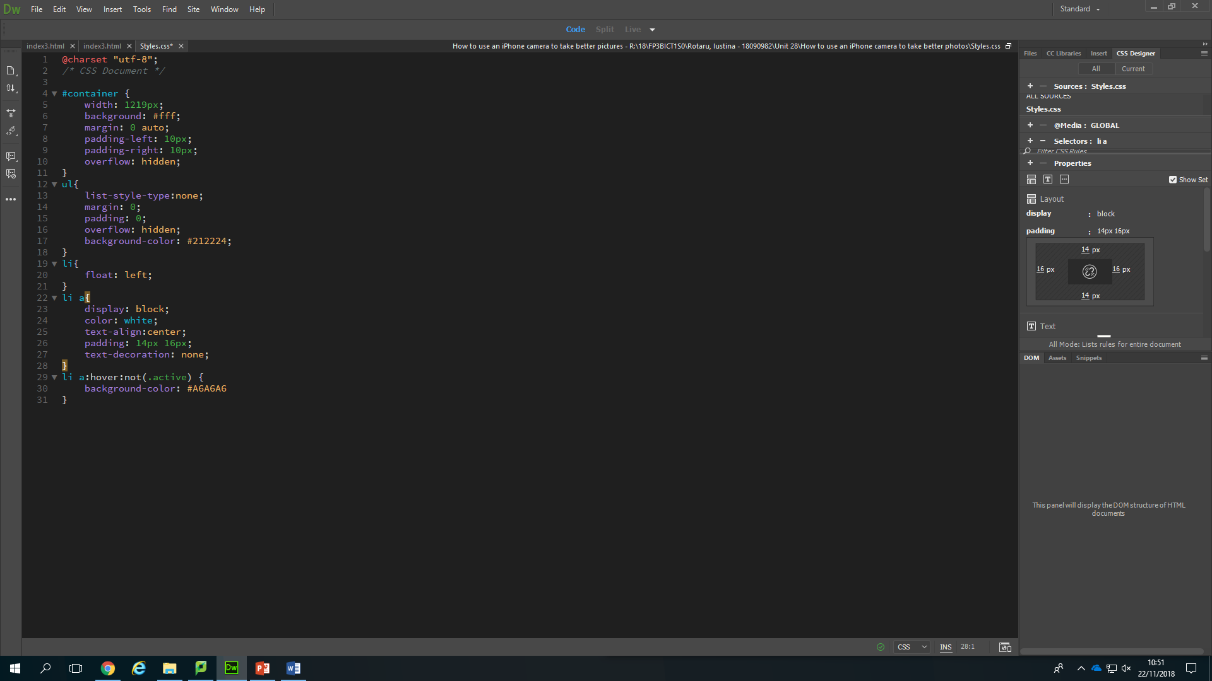The display: block; is to display the links as block elements.

I changed the text colour to white, centred it and selected a 14px, 16px padding.

I wrote this so my buttons will change their colour from a dark grey to a light one when you click on it.

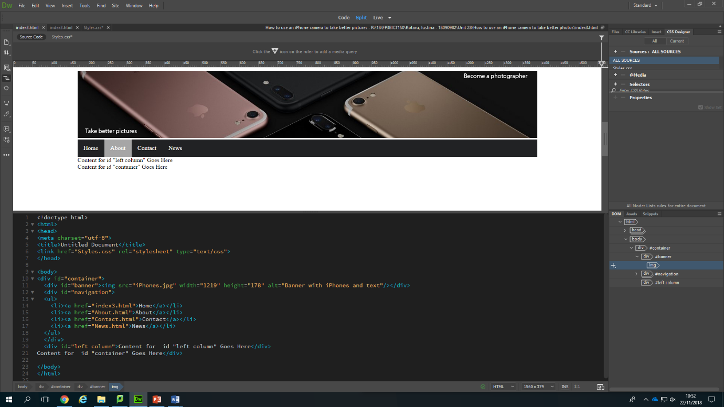

This is what my navigation bar looked after.

1. 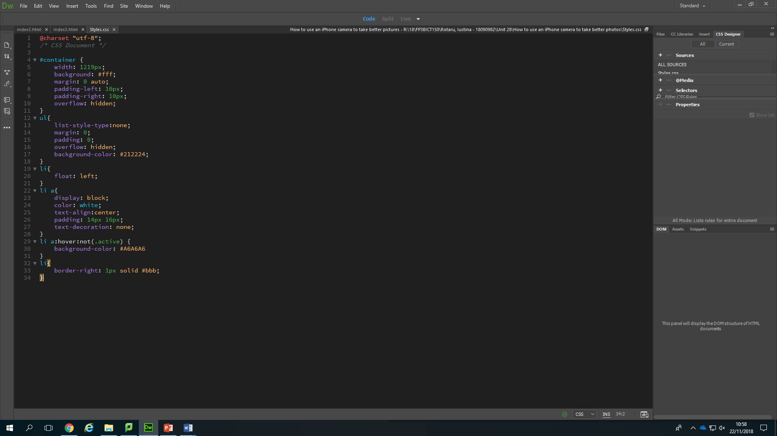 Creates a little vertical grey line between the buttons.

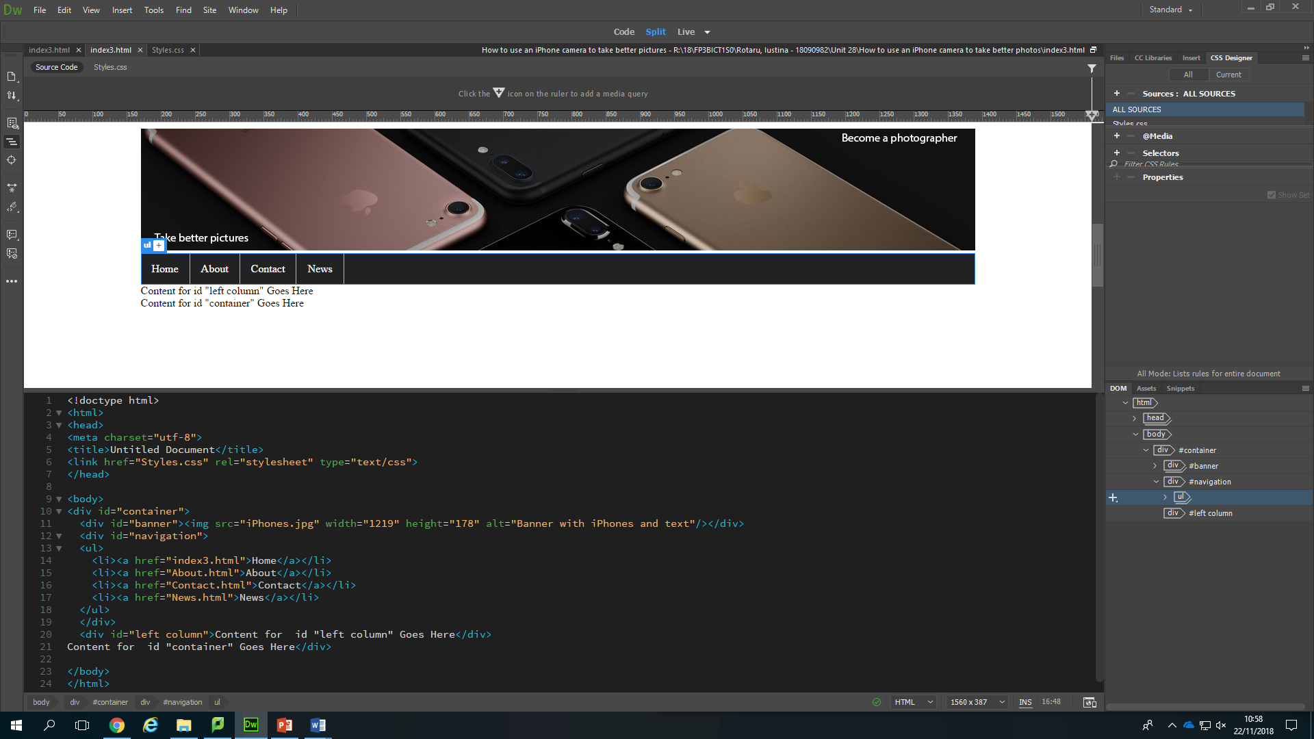

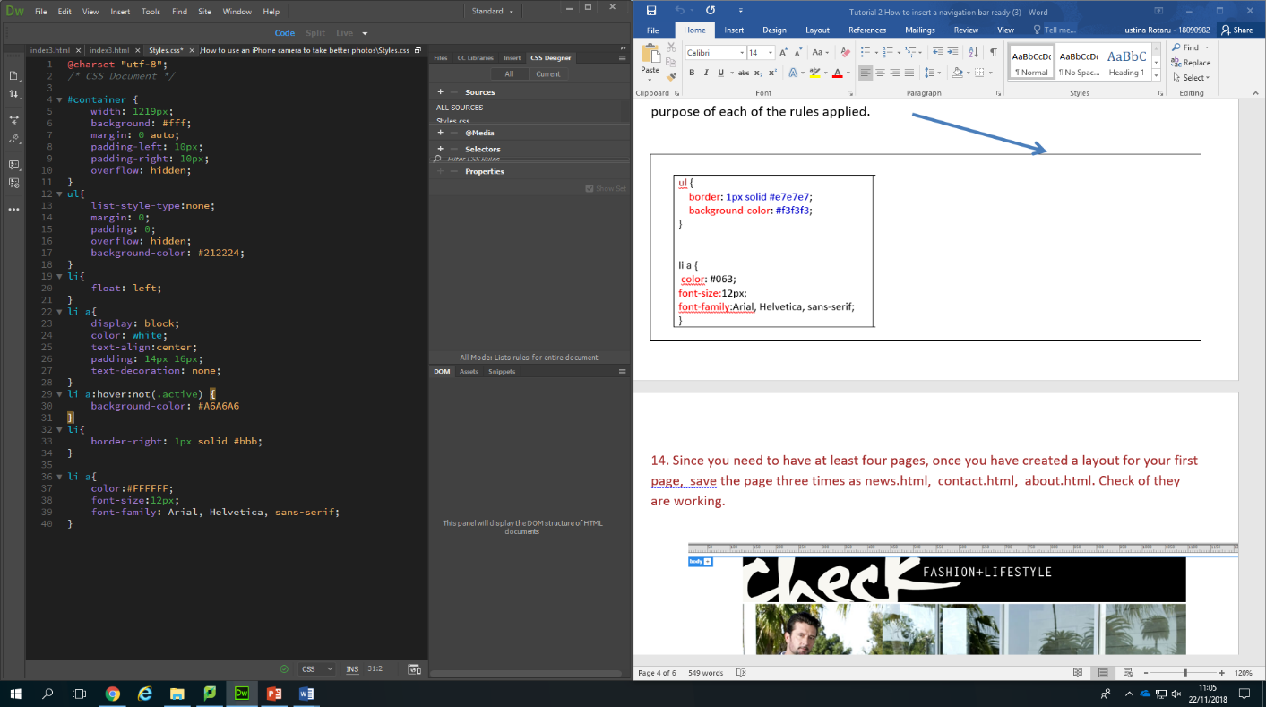

1. Changes the text’s font.
2. 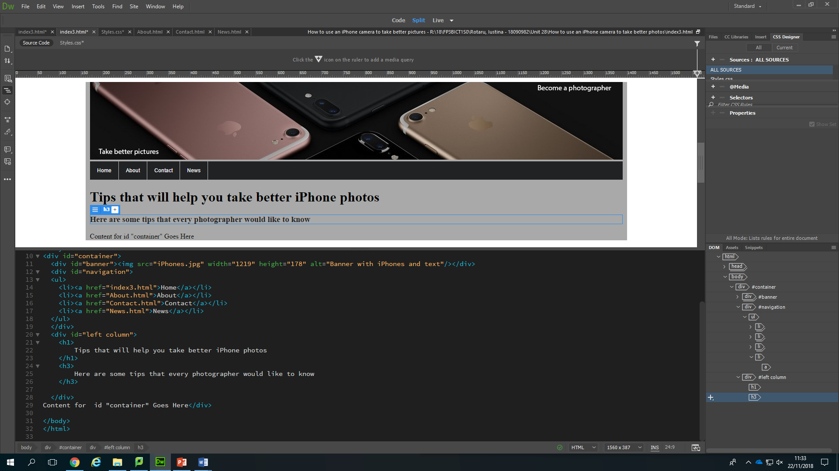After creating the navigation bar, I decided to start writing on my first page, “Home”. To do this, I needed to create another div tag called “left column” and start writing my headings in. My first heading is “h1” because I want it to be bigger than the others, and my next heading is “h3” because I found the size of “h2” too big.

Results:

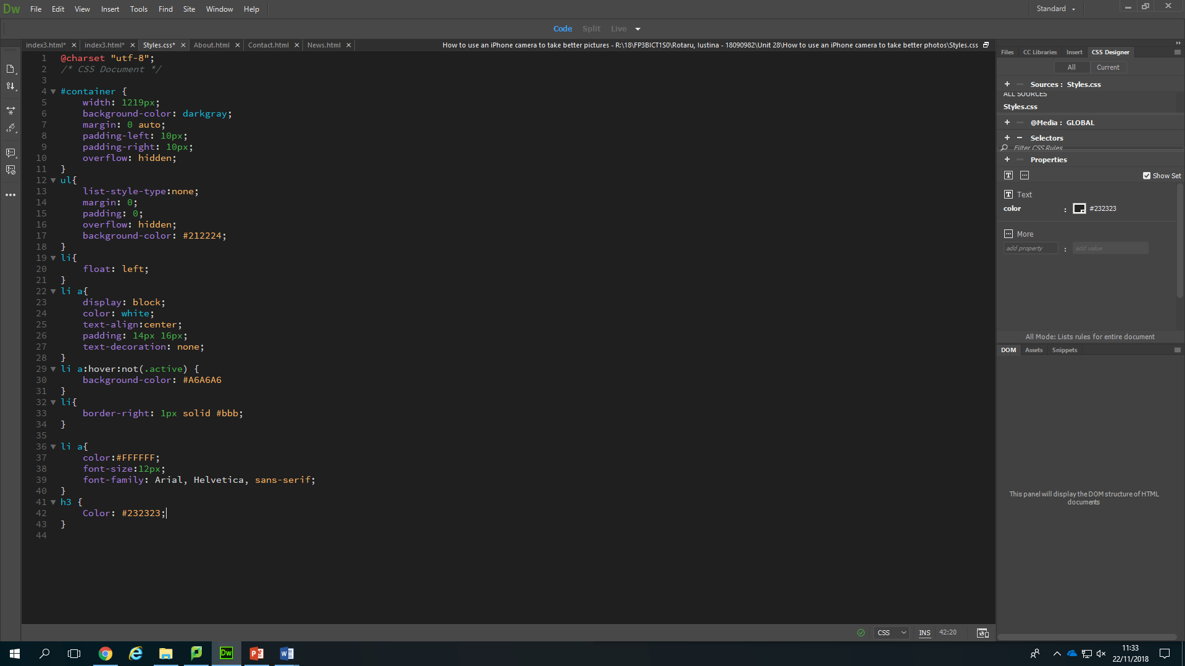

1. Back to my styles sheet, I created a rule for my second heading to change the colour to a darker black, a I thought the one that it already had was sort of grey.
2. 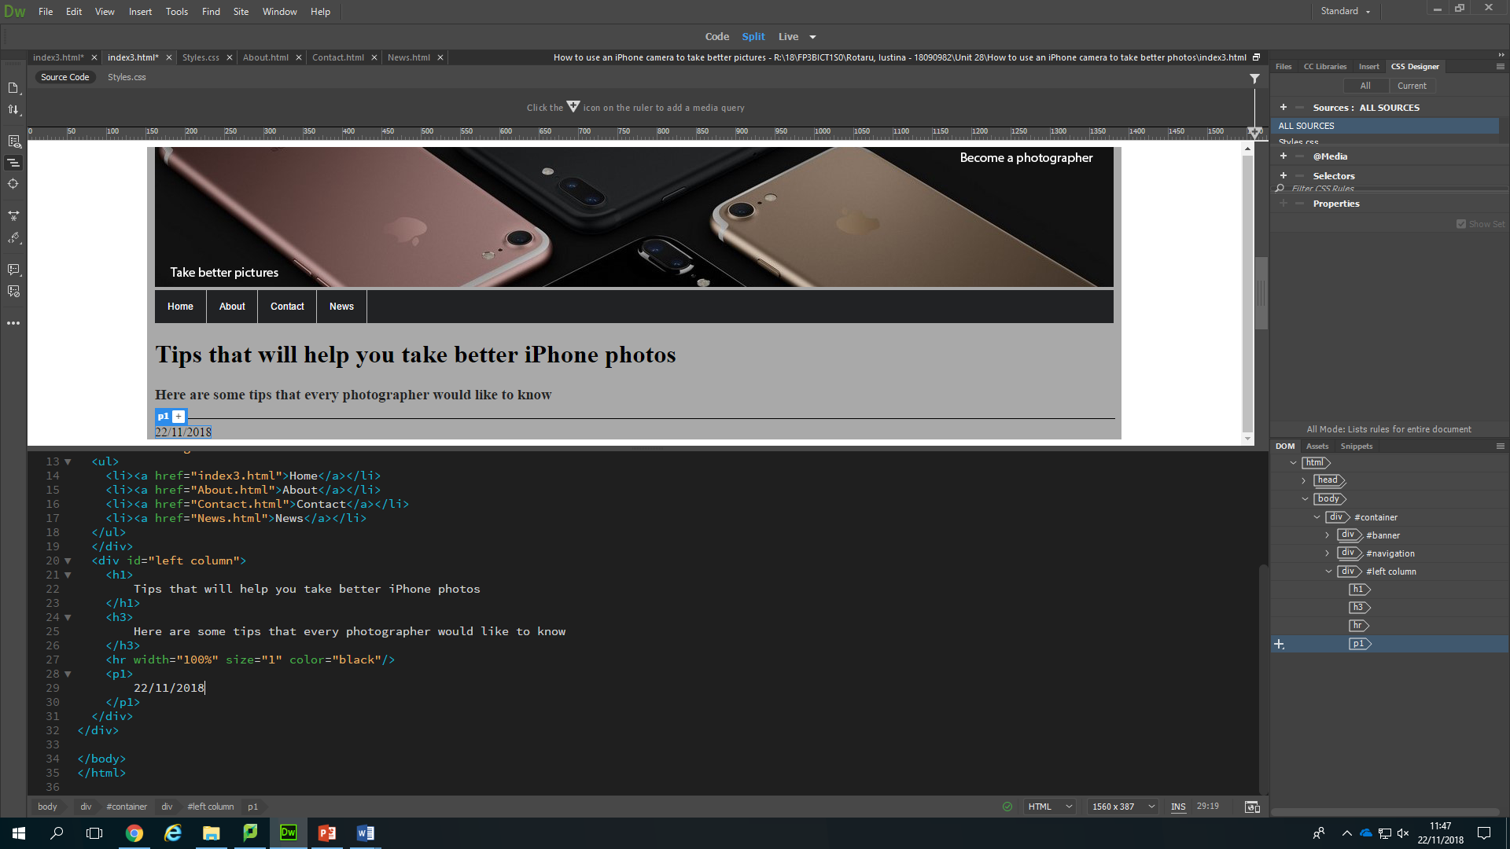Next, I wanted to create a horizontal line that will separe everything that I created up to know, from everything that I am about create from now on, so I wrote the “hr” tag, to do it.

After this, I created a paragraph by using the “p” tags, and wrote the date when I started the website, inside it.

Results:

1. 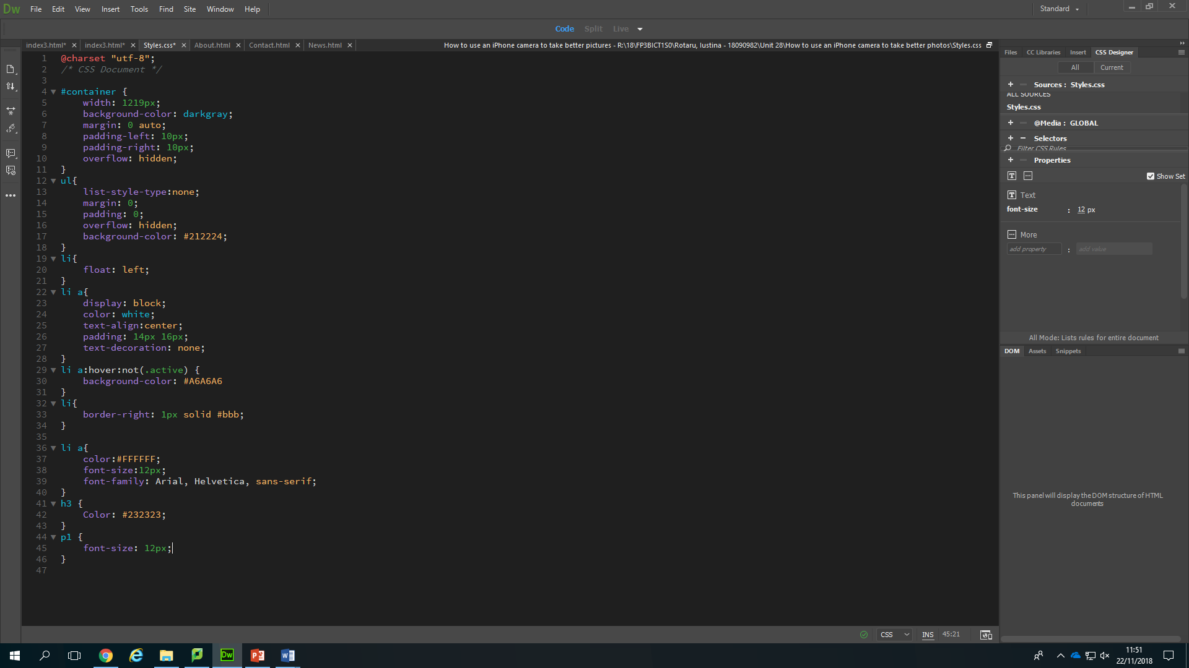After doing this, I decided to change the font size of my first paragraph because I thought it was too big, so I created a rule to make it smaller.
2. Next, I decided to start adding some more text and images:

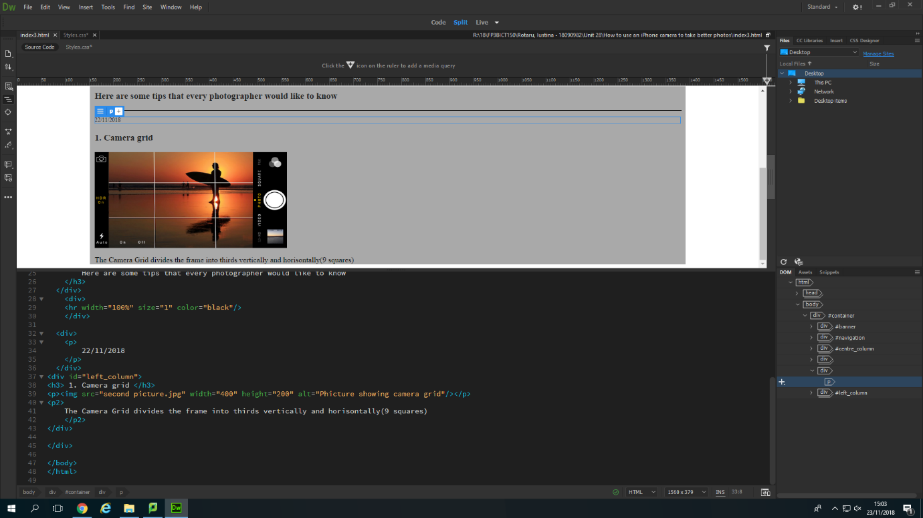

1. 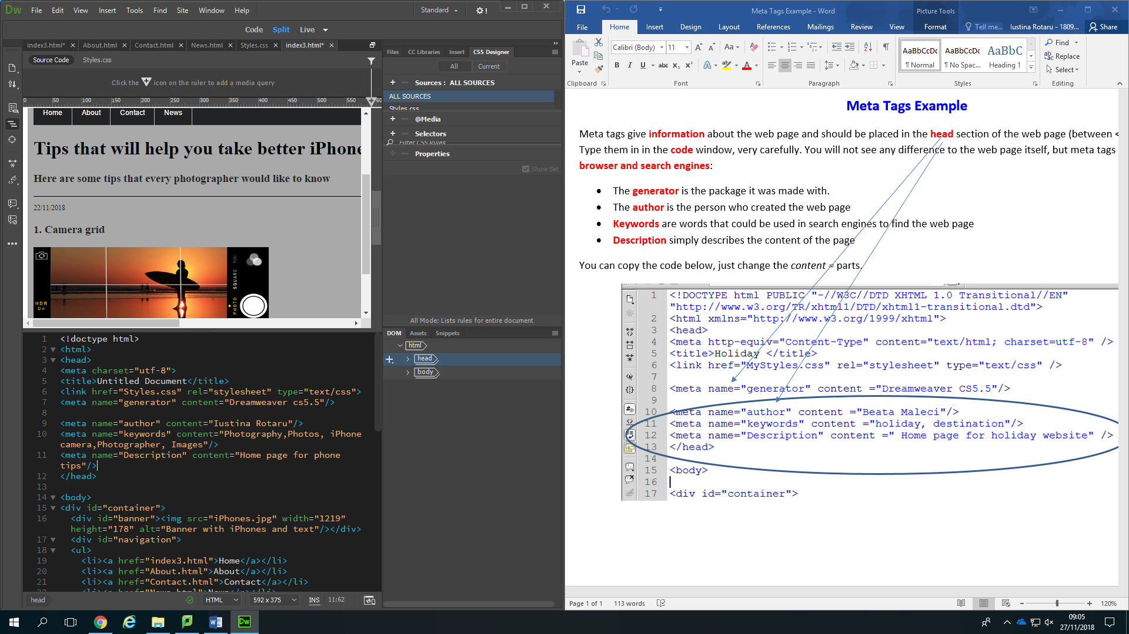To create meta tags, I only needed to copy these codes, but change the content parts.
2. 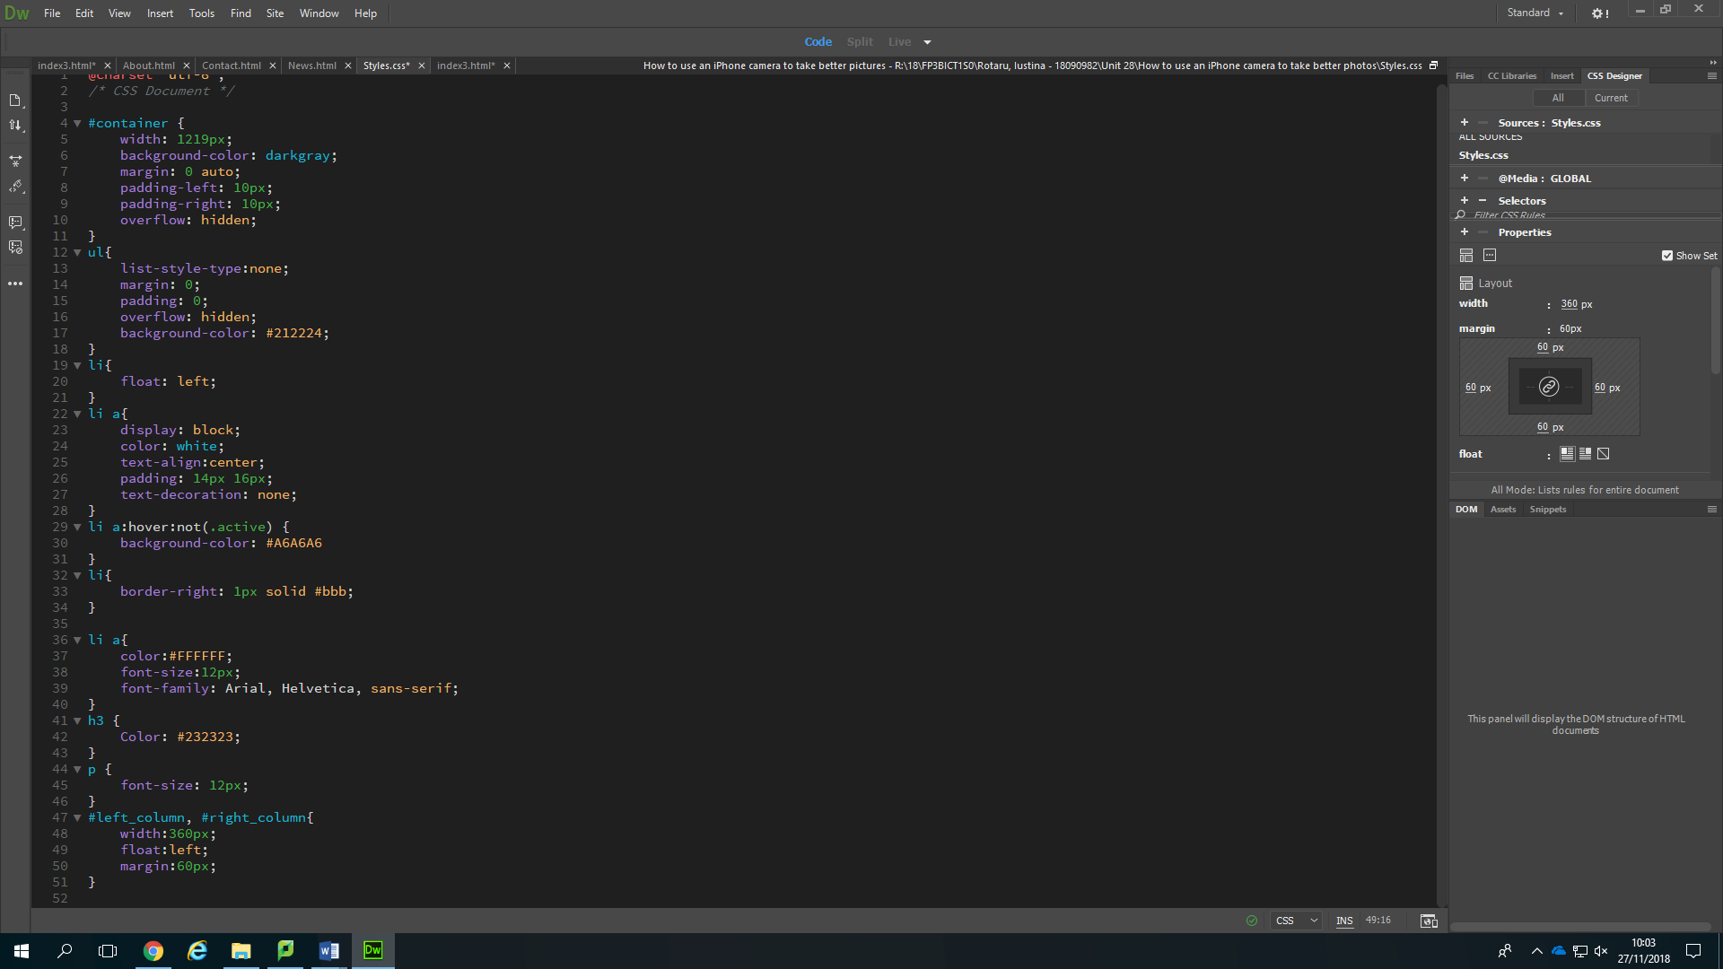After doing these, I decided to create another column on my home page, that will float to the left, so I created a rule for my right column, after I finished putting my headings and paragraphs inside of it.

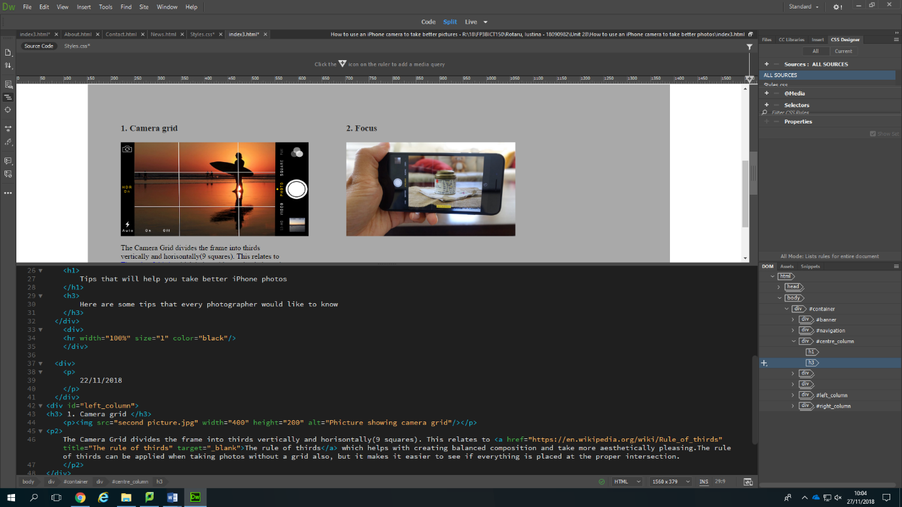Result:

1. 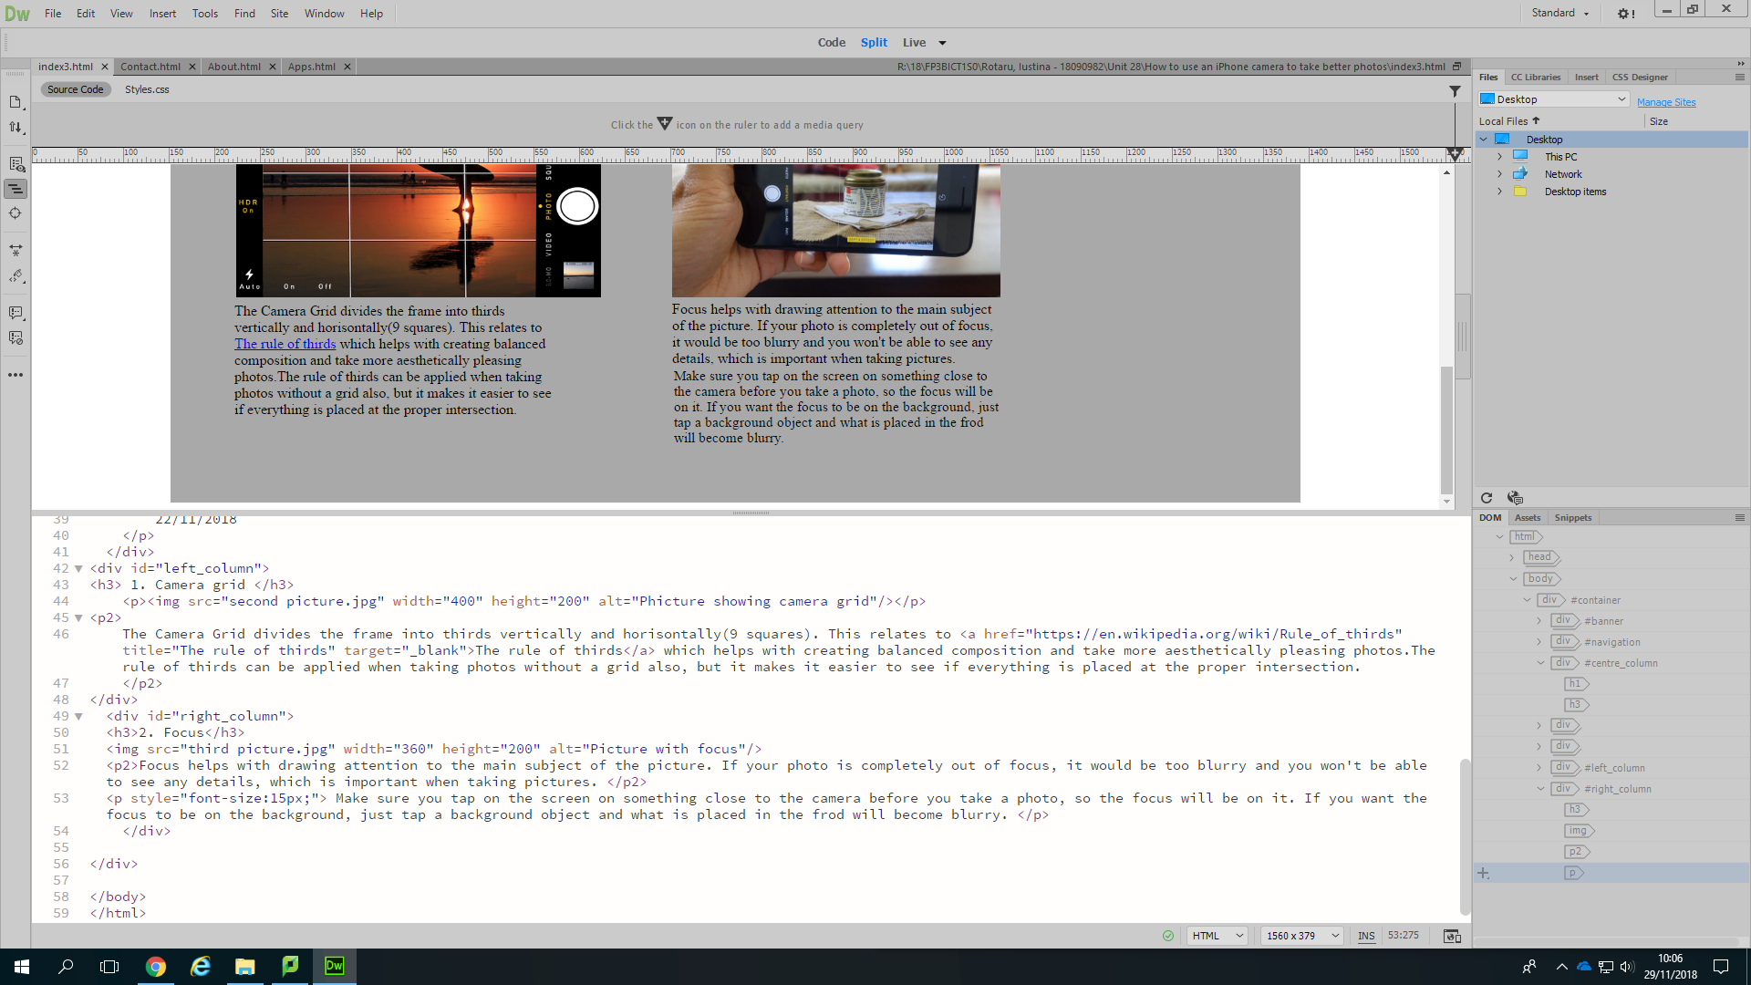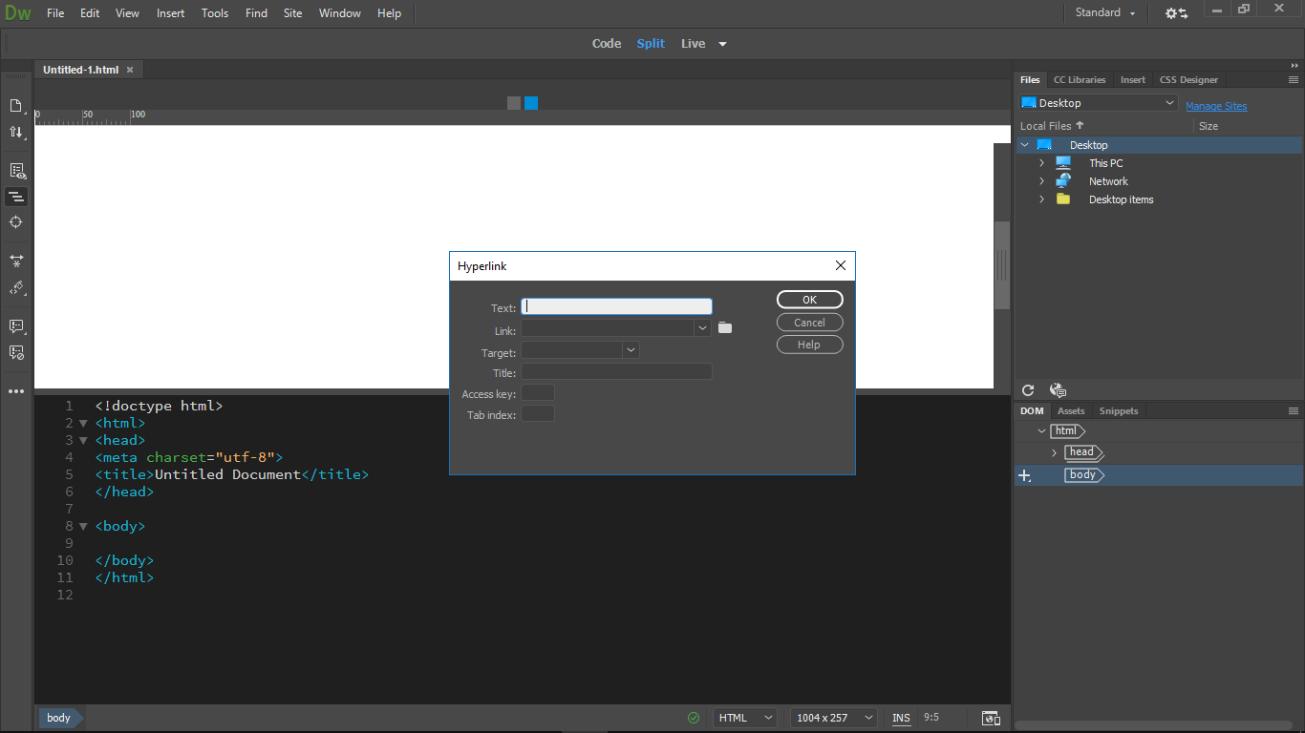Next, I only added some more paragraphs, just as I did when adding the date, but also added an external link. To do so, I needed to select the text that I wanted to use as the link (“The rule of thirds”), then go into “Insert” and select “hyperlink”, which will bring up the hyperlink box. I completed it with the text I wanted to link, the link I wanted to use and “blank” for target.

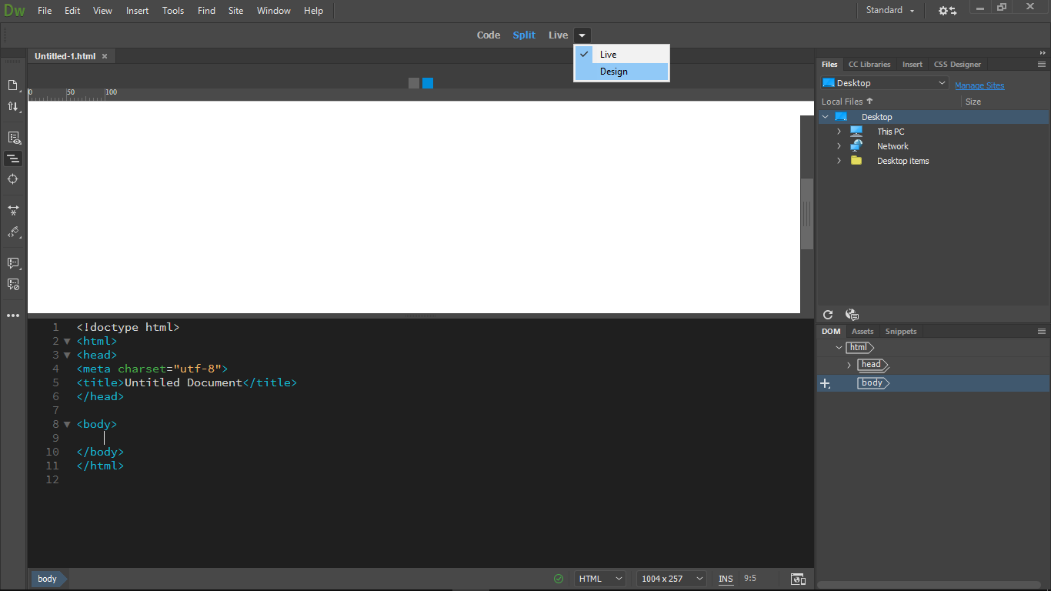After doing all these things, I only had to add some more headings, paragraphs and images, and my home page was done, so I went into my contact page.

1. For my contact page I needed a form, so the first thing I needed to do was to make sure I changed the view from live to design.
2. I went to “Insert” and clicked on “Form” which created a read outline.
3. I clicked on the red outline and then opened the properties panel and changed the ID to “Contact”.
4. I then clicked on insert again -> Form -> text, to create a text box. After the text box was created, I had to change the values to “Surname” for example, then to right click on the box, select properties and select “Contact” where it says “Form”.

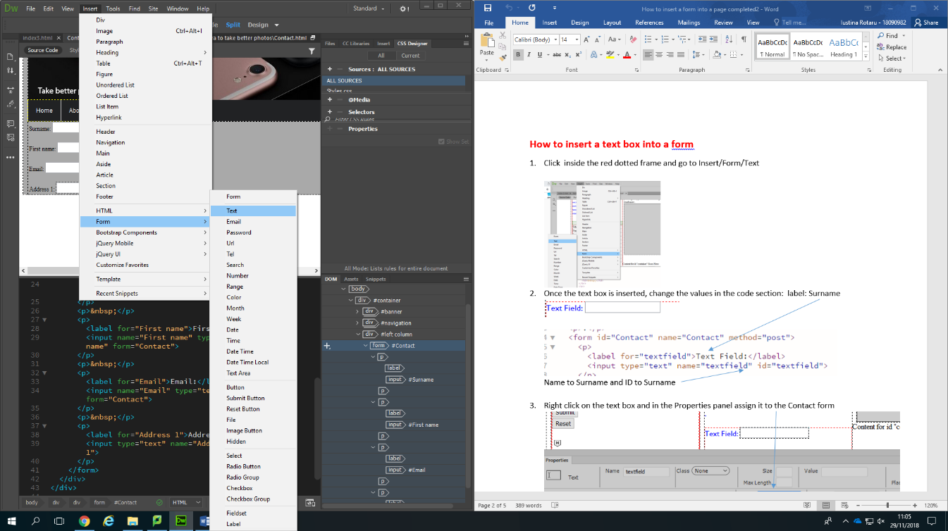

1. 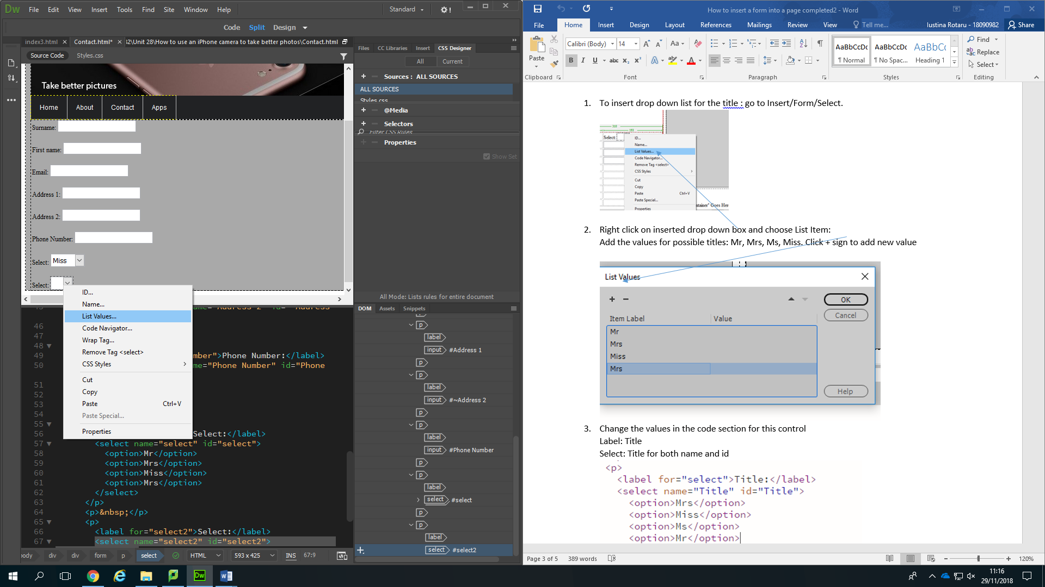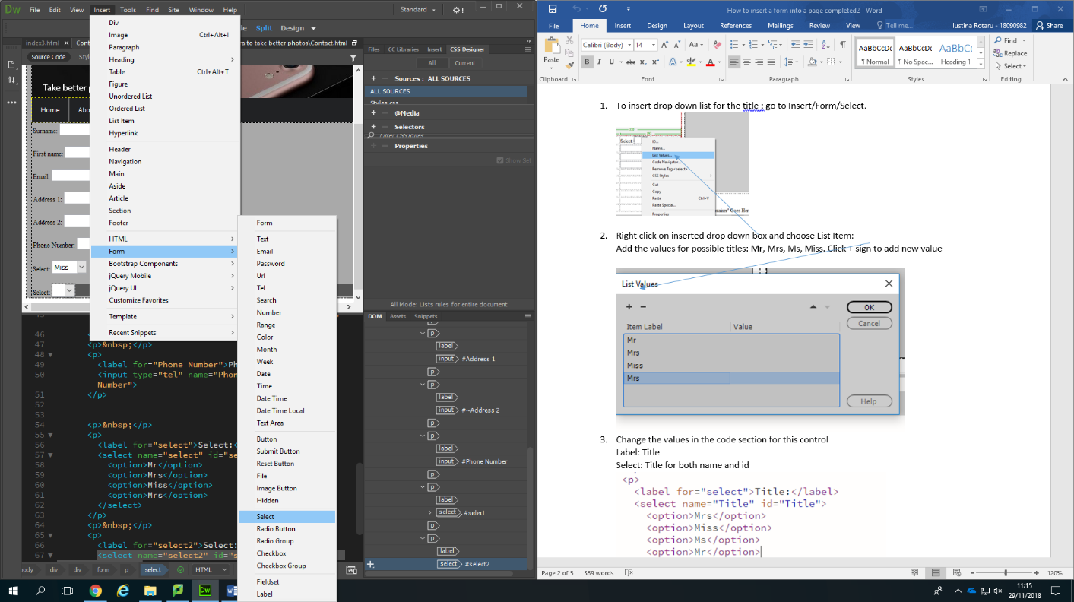To create the “drop down list” I had to select “select” from the Insert -> Form, change the values, right click on the arrow, then select “list values to do so.

(Click on “+” to add new values)

(also, right click on it to get properties and assign it to the contact form)

Assigning to the contact form was needed for everything I added in there.

1. The last things I needed for my form were reset and submit buttons.

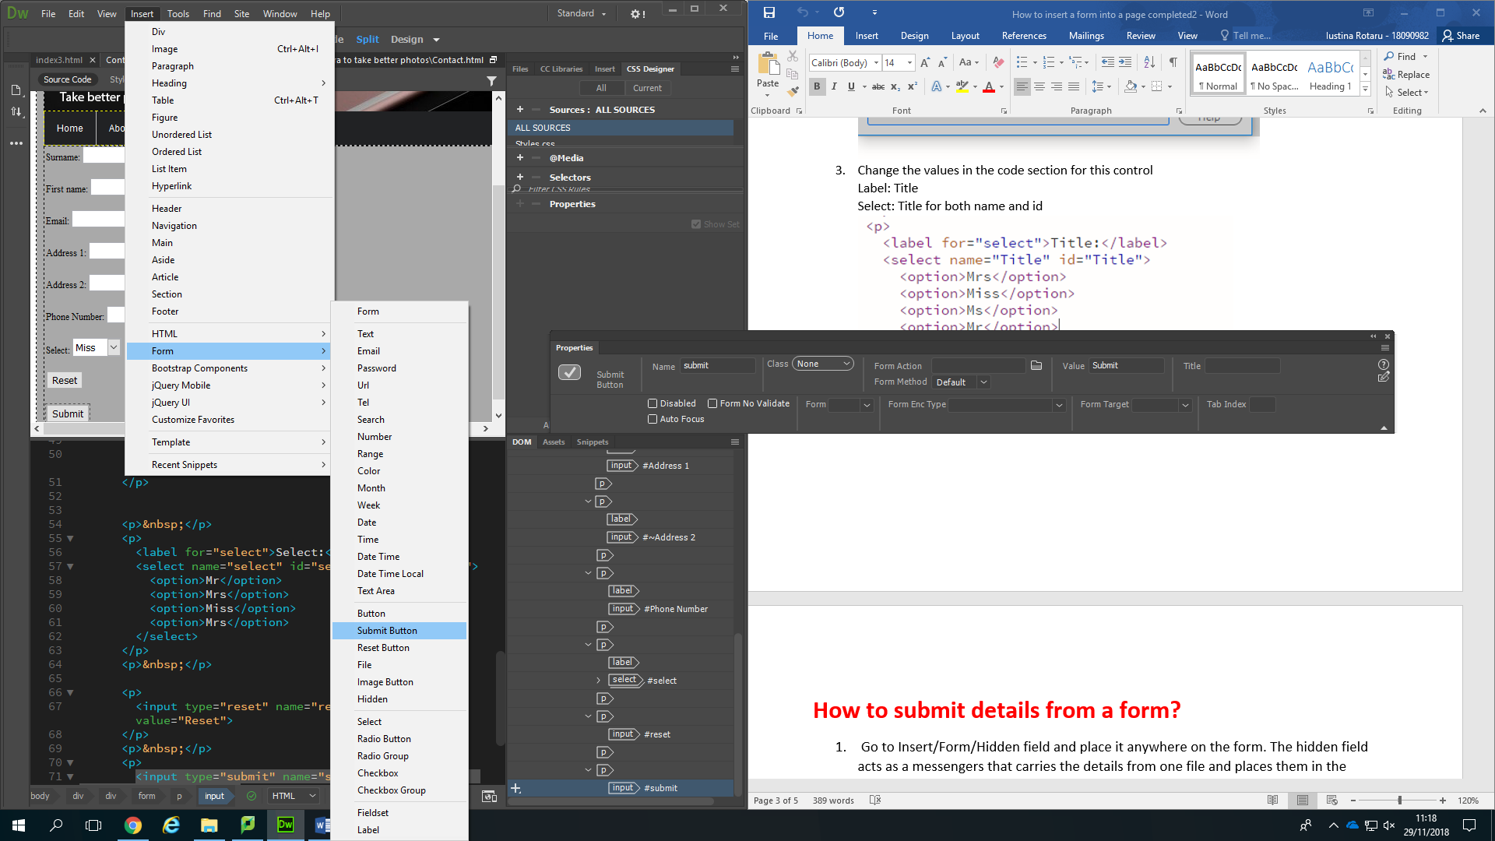To insert them, I just needed to find the in “Insert”> “Form” as “submit button” and “Reset button”.

1. Next, I needed to go to Insert> Form > Hidden field and to insert it wherever
2. Select the hidden field and get the properties panel.
3. Change the name to “filename” then the value to “enquiries.csv”
4. Select the outline of the form and get the properties panel.

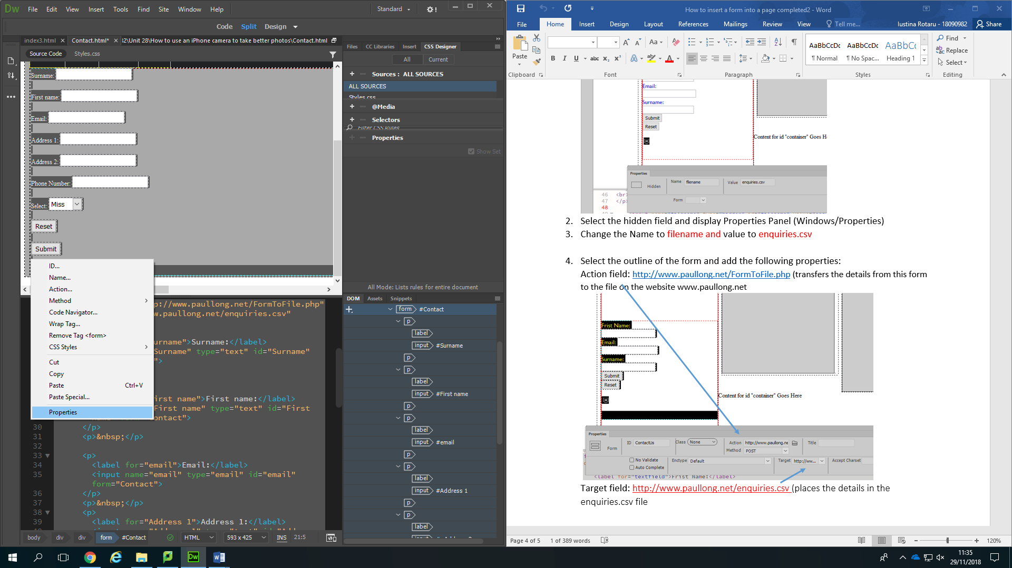

1. Target to <http://www.paullong.net/enquiries.csv>
2. 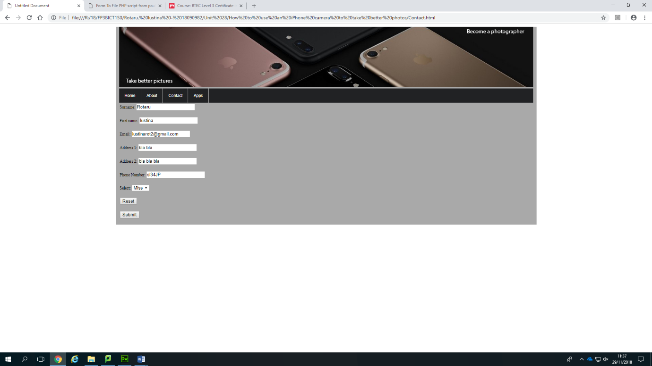 This is the final result.
3. 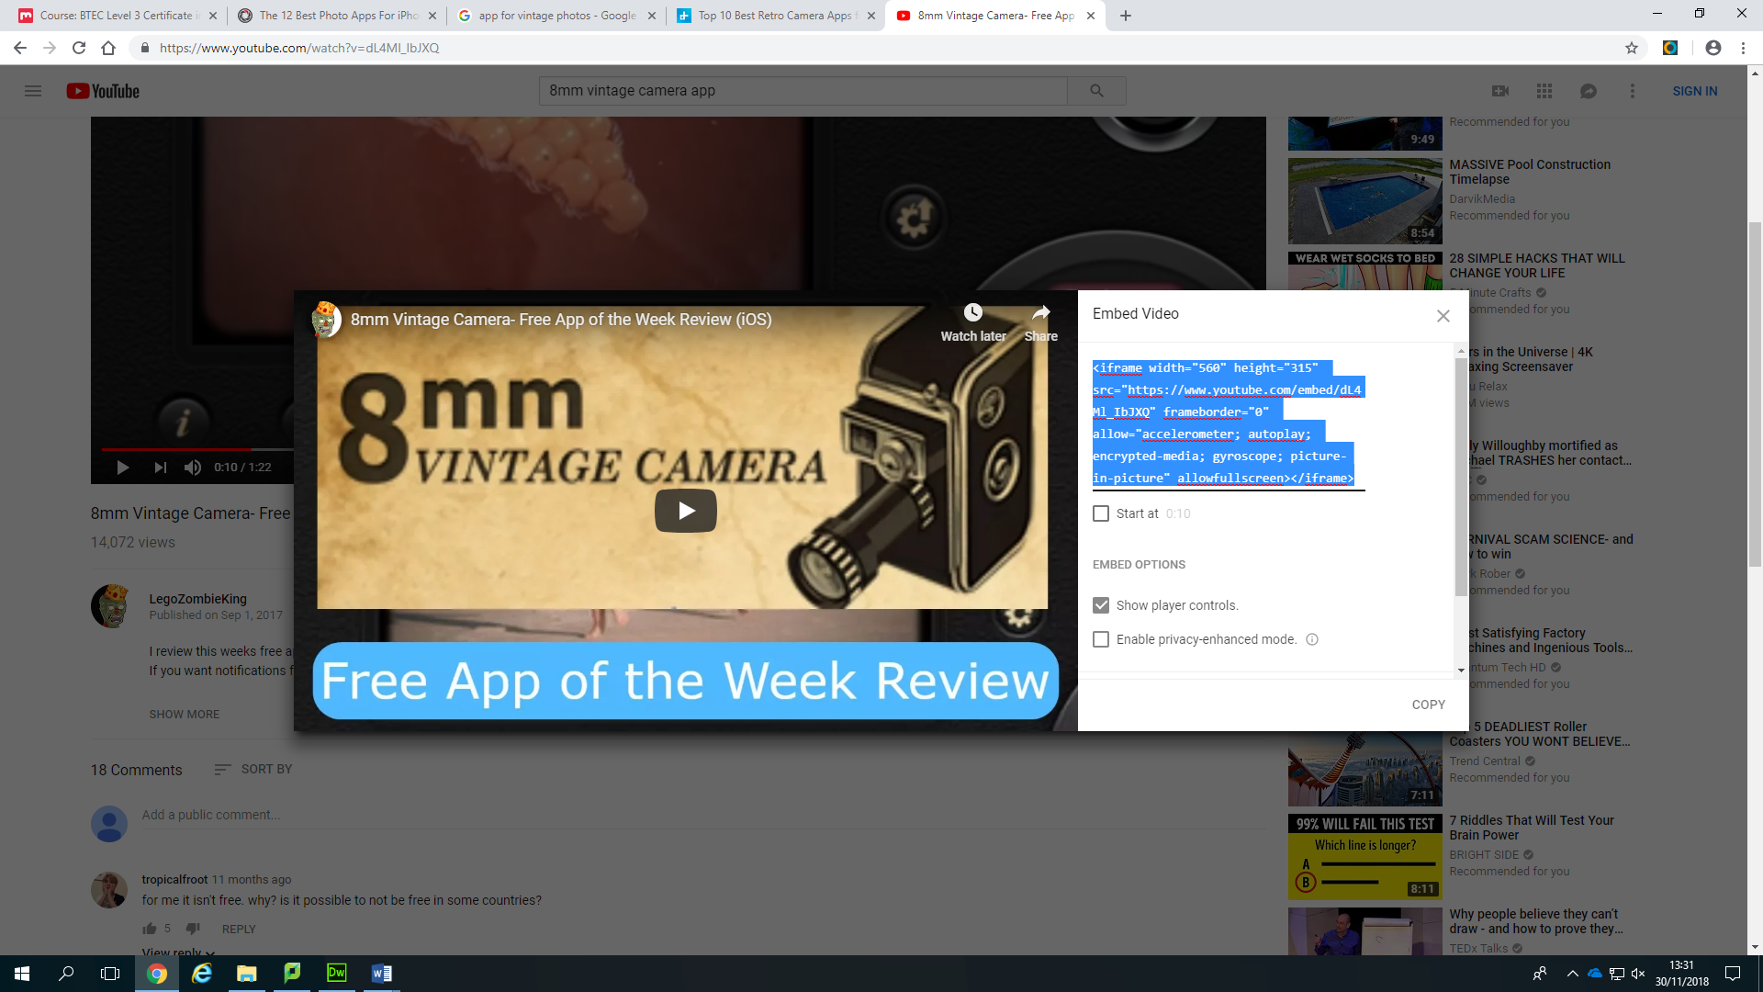After finishing the Contact page, I started creating the “Apps” one. First, I added some headings and paragraphs, then I needed some videos. To add a video, I have to go on YouTube, select the video I want to add, click on the share button, then on the “embedded” one, copy the code that I am given and paste it in my code sheet.

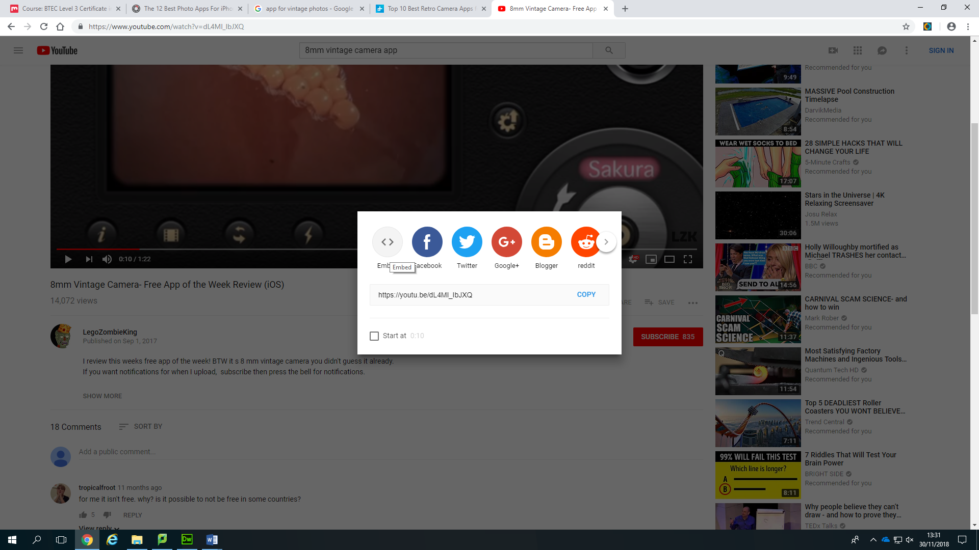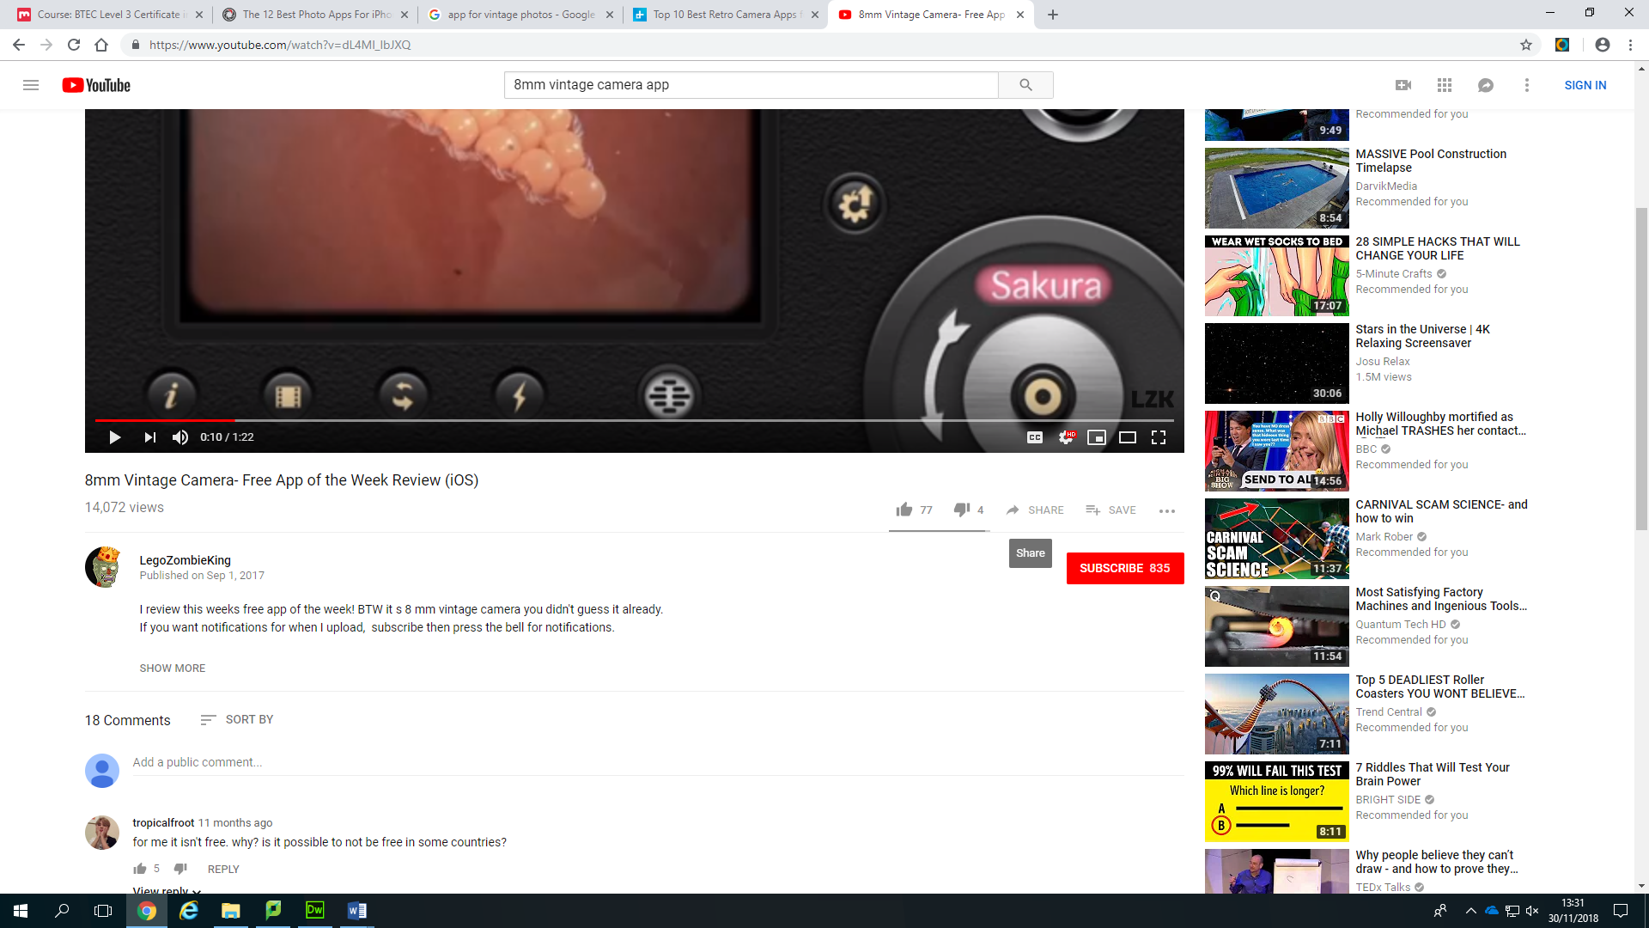

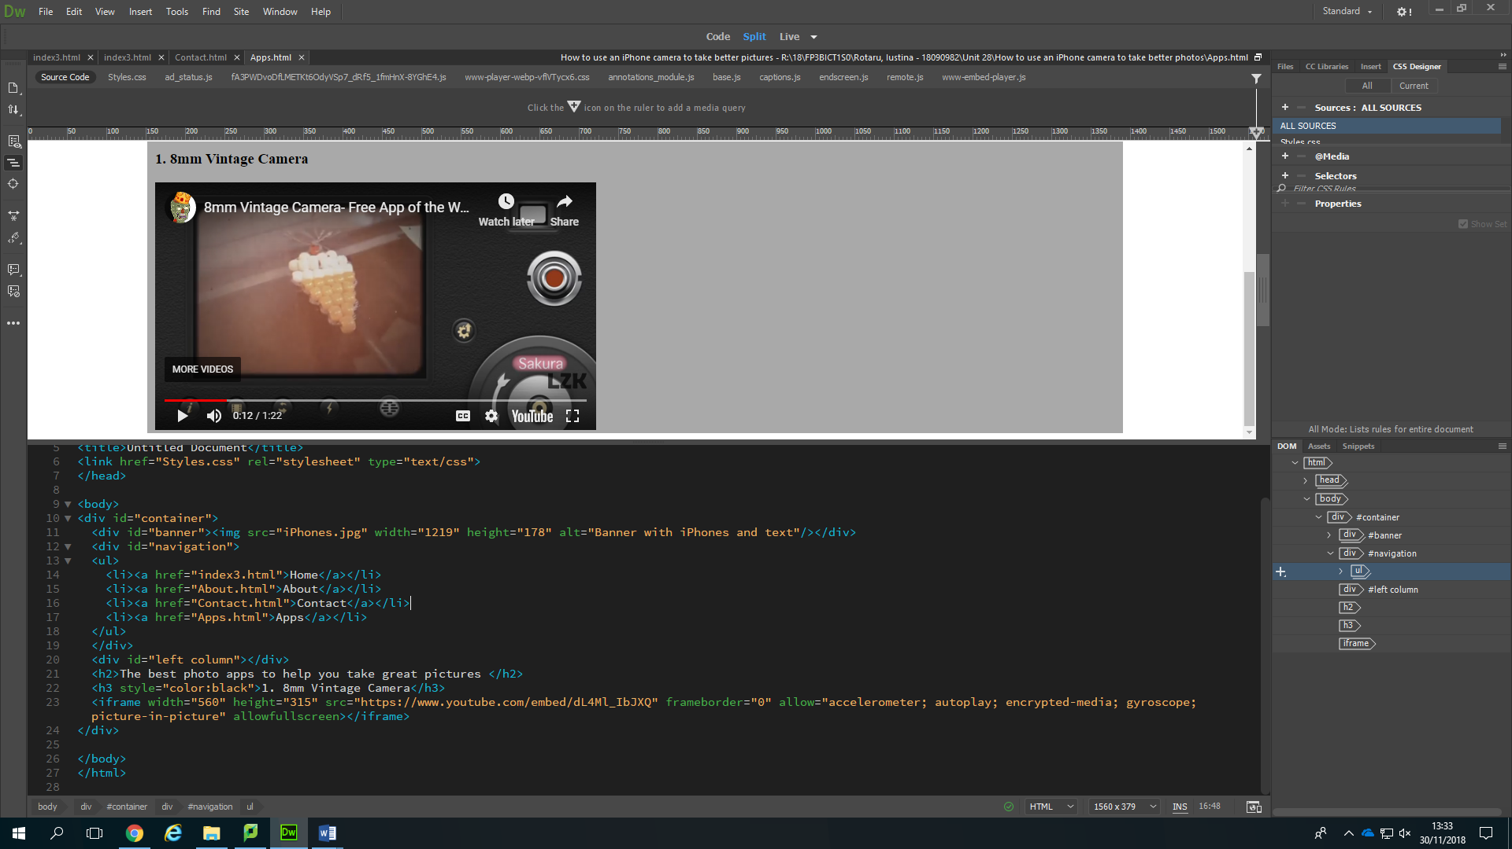Result:

1. After all these, I completed all my pages by adding more text, images and videos, then went onto adding java script for welcoming everyone on my website. To do this, I only needed to copy this code and paste it wherever I wanted my welcoming message to appear. The first part of the code is to create the “please type in your name” message for every user so they will know what they need to do and the next part is for the message that is displayed after the user inserts its name.

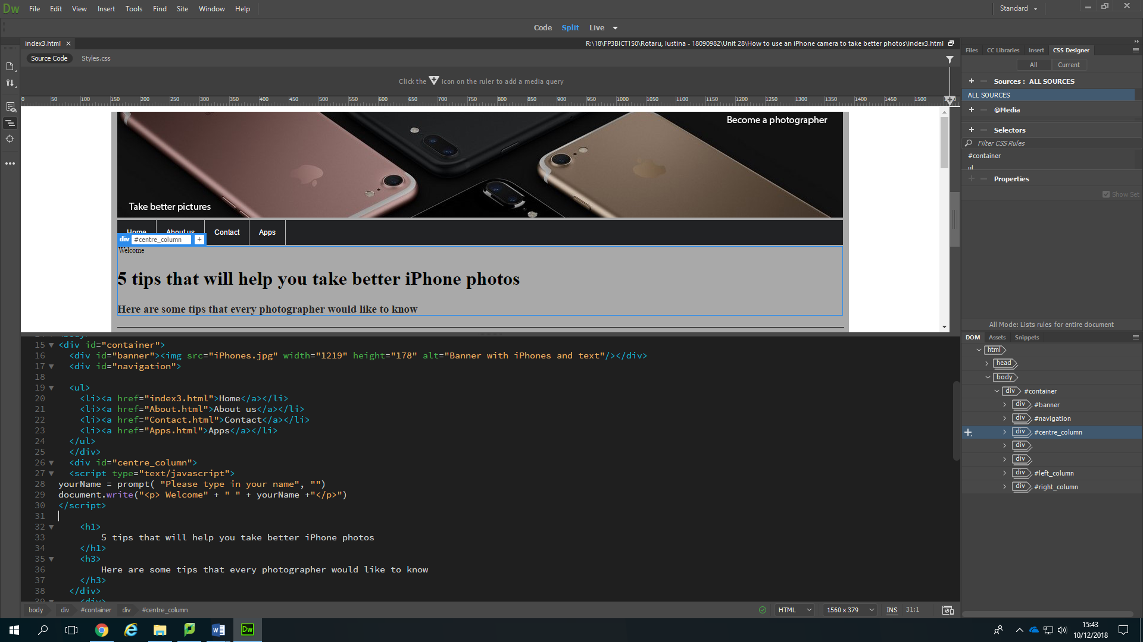

**Corrections**

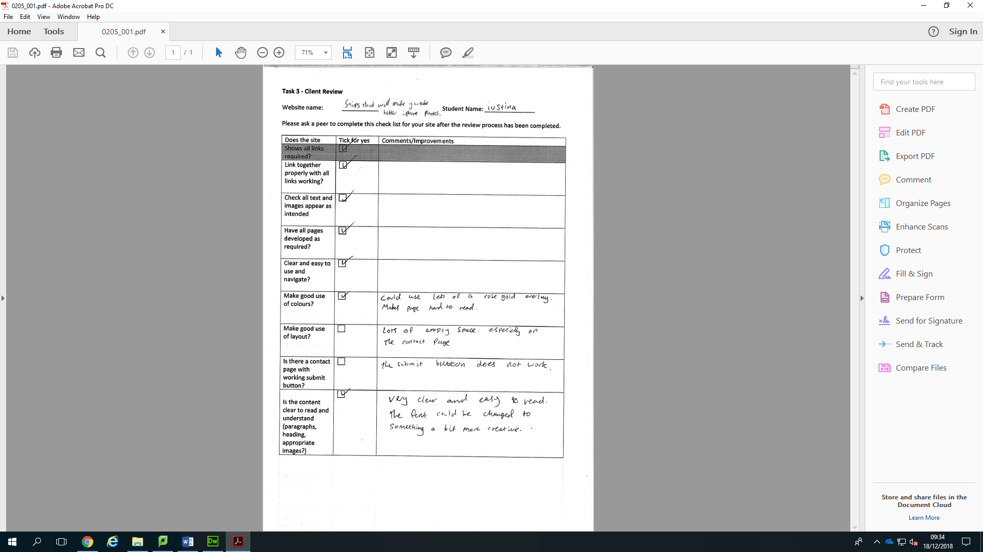

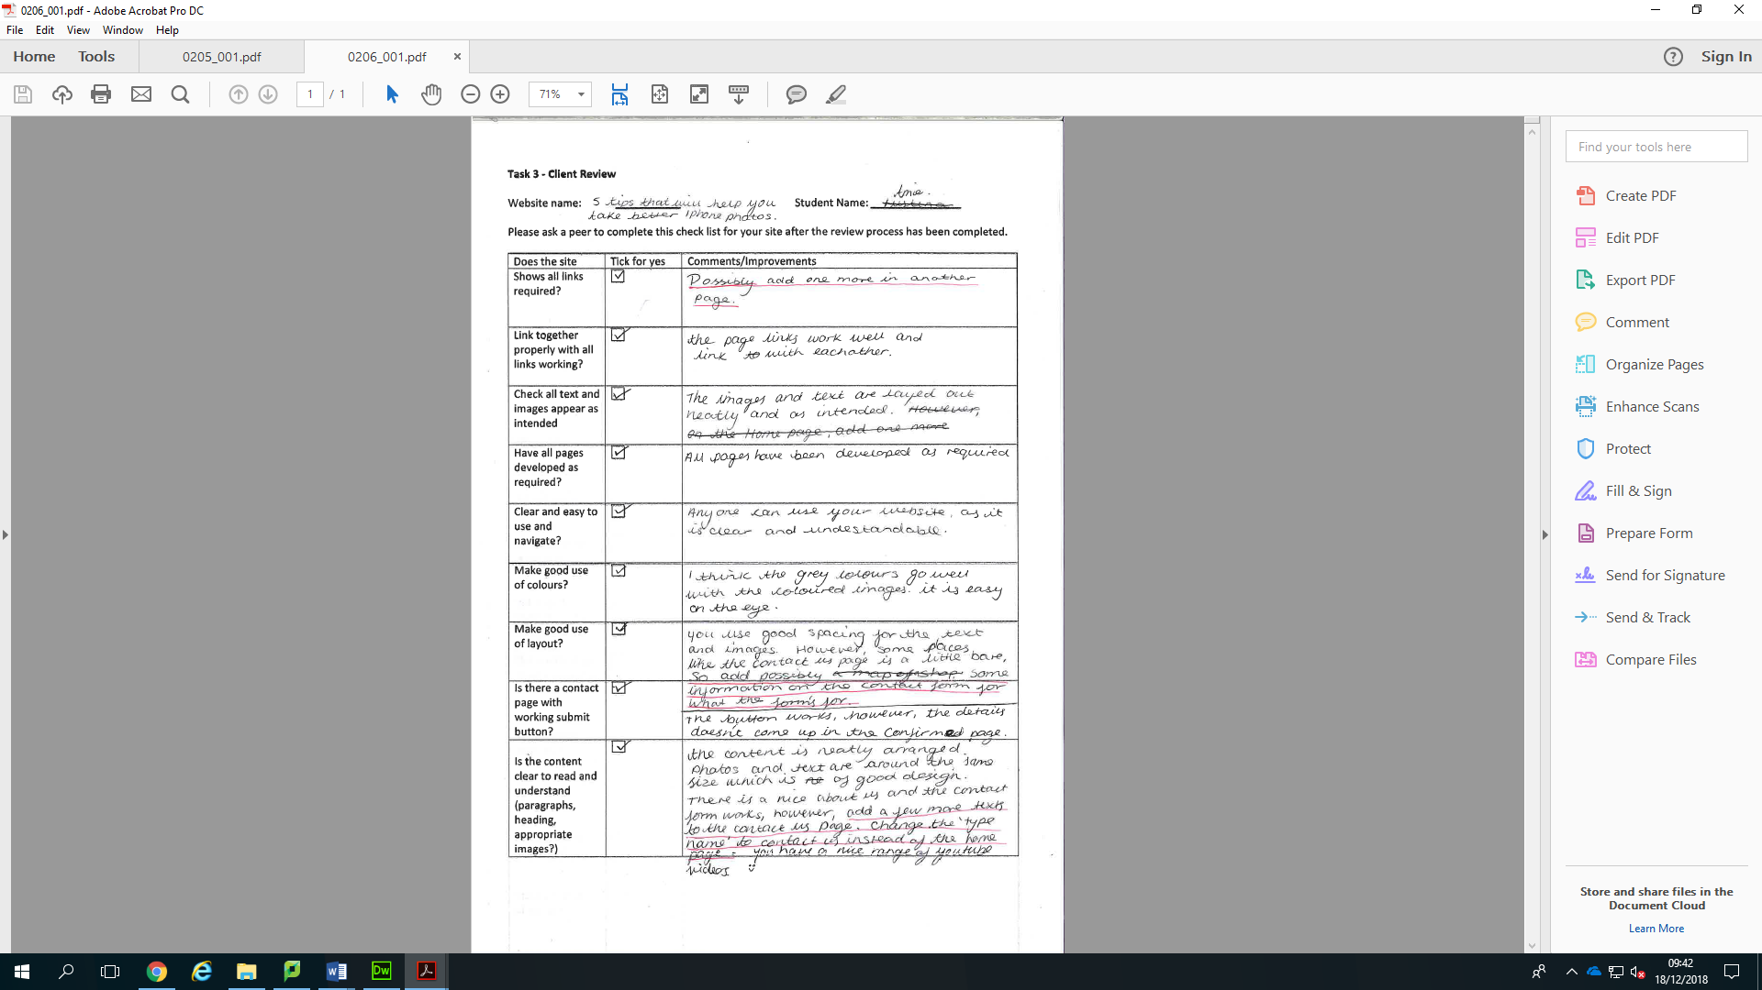

After getting these feedbacks, I added some more hyperlinks:

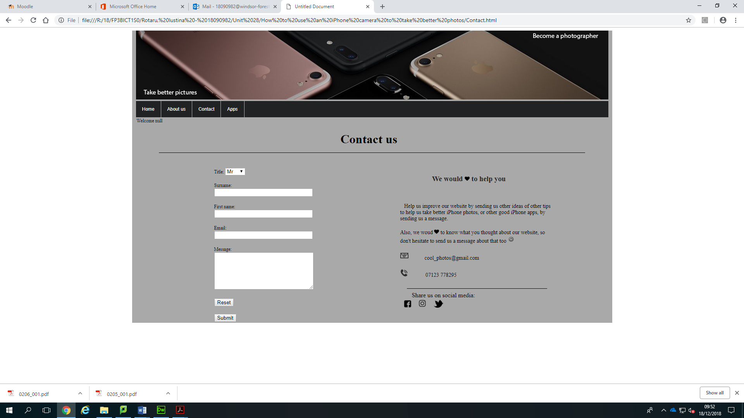

I have done this by inserting the pictures of the logos and then completing the “hyperlink” box that I have been given after selecting it.

I filled the empty space:



As only the left side of the page was filled in, I decided to fill my other side by writing some more about how people can contact me if they need to.

Then moved the java script to my contact page: (Only by copying its code and inserting it on the top of my contact page)

